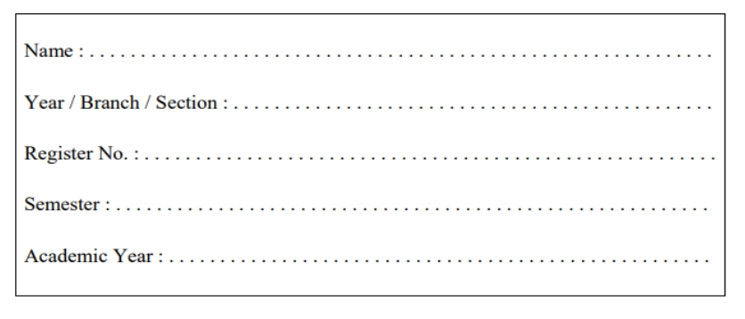

**RAJALAKSHMI ENGINEERING COLLEGE**

**RAJALAKSHMI NAGAR, THANDALAM – 602 105**

**CS23221**

**PYTHON PROGRAMMING LAB Laboratory Observation Note Book**

KARTHIKHA SRE M

ICSE 'C'

2116230701143

II

2023-2024

**Department of Computer Science and Engineering** | **Rajalakshmi Engineering College** 1

**Department of Computer Science and Engineering** | **Rajalakshmi Engineering College** 2

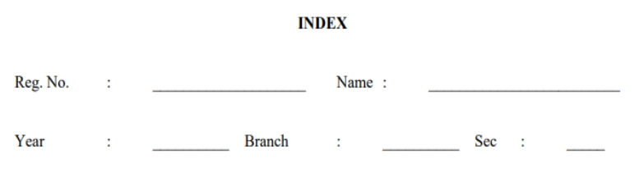

2116230701143 KARTHIKHA SRE M

I CSE C

**S.**

**No.**

**Date**

**Title**

**Page**

**No.**

**Teacher’s**

**Signature /**

**Remarks**

**Introduction to python-Variables-Datatypes-Input/Output-Formatting**

1.1 1.2 1.3 1.4 1.5 1.6

2.1 2.2 2.3 2.4 2.5 2.6 2.7 2.8 2.9

2.10

3.1 3.2 3.3 3.4

12.03.24

12.03.24

12.03.24

12.03.24

12.03.24

12.03.24

20.03.24

20.03.24

20.03.24 20.03.24 20.03.24

20.03.24

20.03.24 20.03.24 20.03.24

20.03.24

28.03.24 28.03.24 28.03.24

28.03.24

Converting Input Strings Gross salary

Square Root Gain percent Deposits Carpenter

**Operators in Python**

Widgets and Gizmos

Doll Sings Birthday party Hamming Weight

Compound Interest Eligible to donate blood C or D

Troy Battle Tax and Tip

Return last digit of the given number

**Selection Structures in Python**

Admission eligibility Classifying triangles Electricity Bill IN/OUT

**Department of Computer Science and Engineering** | **Rajalakshmi Engineering College** 3

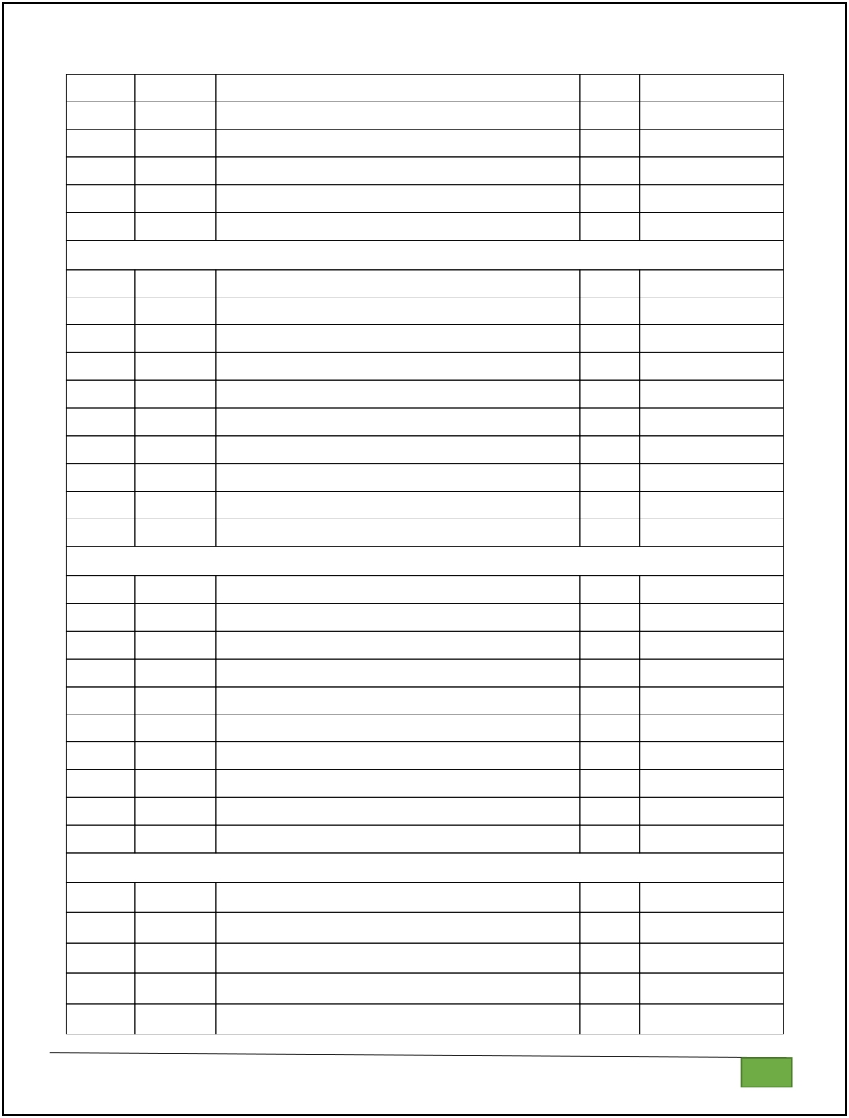

3.5 3.6 3.7 3.8 3.9

3.10

4.1 4.2 4.3 4.4 4.5 4.6 4.7 4.8 4.9

4.10

5.1 5.2 5.3 5.4 5.5 5.6 5.7 5.8 5.9

5.10

6.1 6.2 6.3 6.4 6.5

28.03.24 28.03.24 28.03.24 28.03.24 28.03.24 28.03.24

01.05.24 01.05.24 01.05.24 010524

01.05.24 01.05.24 01.05.24 01.05.24 01.05.24 01.05.24

03.05.24 03.05.24 03.05.24 03.05.24

03.05.24 03.05.24 03.05.24 03.05.24

03.05.24

03.05.24

04.05.24 04.05.24 04.05.24 04.05.24

04.05.24

Vowel or Constant

Leap Year

Month name to Days Pythagorean triple Second Last Digit Chinese Zodiac

**Algorithmic Approach: Iteration Control Structures**

Factors of a Number Non-Repeated Digits Count Prime Checking

Next Perfect Square Nth Fibonacci Disarium Number Sum of Series Unique Digits Count

Product of single digits

Perfect Square After adding One

**Strings in Python**

Count chars

Decompress the String

First N Common Characters Remove Characters

Remove Palindrome Words

Return Second Word in Uppercase

Reverse String

String characters balance Test

Unique Names

Username Domain Extension

**List in Python**

Monotonic array

Check pair with difference k .

Count Elements

Distinct Elements in an Array Element Insertion

**Department of Computer Science and Engineering** | **Rajalakshmi Engineering College** 4

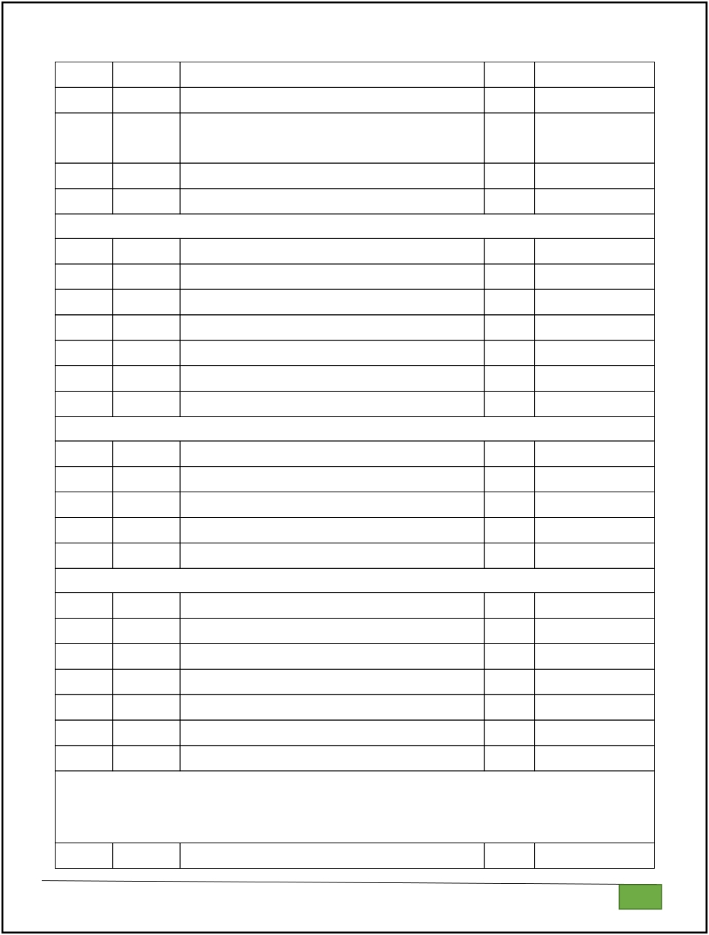

6.6 6.7 6.8

6.9

6.10

7.1 7.2 7.3 7.4 7.5 7.6 7.7

8.1 8.2 8.3 8.4 8.5

9.1 9.2 9.3 9.4 9.5 9.6 9.7

10.1

04.05.24

04.05.24 04.05.24 04.05.24

04.05.24

01.06.24 01.06.24 01.06.24 01.06.24

01.06.24 01.06.24 01.06.24

01.06.24 01.06.24 01.06.24 01.06.24 01.06.24

02.06.24 02.06.24 02.06.24 02.06.24

02.06.24 02.06.24 02.06.24

03.06.24

Find the Factor Merge list

Merge Two Sorted Arrays Without Duplication

Print Element Location Strictly increasing

**Tuples & Set**

Binary String Check Pair DNA Sequence

Print repeated no Remove repeated malfunctioning keyboard American keyboard

**Dictionary**

Uncommon Words

Sort Dictionary By Values Summation Winner Of Election

Student Record Scramble Score

**Functions** Abundant Number Automorphic number or not Check Product of Digits Christmas Discount

Coin Change Difference Sum Ugly number

**Searching & Sorting**

Merge Sort

**Department of Computer Science and Engineering** | **Rajalakshmi Engineering College** 5

10.2 10.3 10.4 10.5

03.06.24 03.06.24 03.06.24 03.06.24

Bubble Sort Peak Element Binary Search

Frequency of Numbers

**Department of Computer Science and Engineering** | **Rajalakshmi Engineering College** 6

**01 - Introduction to Python-Variables-Datatypes**

**Input/Output-Formatting**

*Sample Output:*

**Department of Computer Science and Engineering** | **Rajalakshmi Engineering College** 7

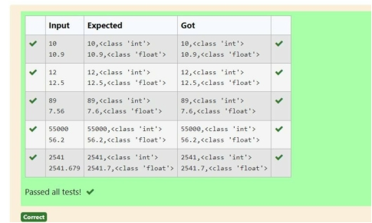

10,<class 'int'>

10.9,<class 'float'>

**For example:**

**Input** **Result**

10

10.9

10,<class 'int'>

10.9,<class 'float'>

**Ex. No.** **:** **1.1** **Date:** 12.03.2024

**Department of Computer Science and Engineering** | **Rajalakshmi Engineering College** 8

**Register No.:** 230701143 **Name:** KA RTH IKH A SRE M

**Converting Input Strings**

Write a program to convert strings to an integer and float and display its type. *Sample Input:*

10

10.9

a=input() b=input() x=int(a) y=float(b)

print(x,type(x),sep=',') print(round(y,1),type(y),sep=',')

*Sample Input:*

10000

*Sample Output:*

**Department of Computer Science and Engineering** | **Rajalakshmi Engineering College** 9

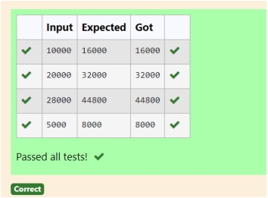

16000

**For example:**

**Input** **Result**

10000 16000

**Department of Computer Science and Engineering** | **Rajalakshmi Engineering College** 10

**Ex. No. Register No.:**

**:**

**1.2**

230701143

**Name:**

**Date:** 12.03.2024

KA RTH IKH A SRE M

**Gross Salary**

Ramesh’s basic salary is input through the keyboard. His dearness allowance is 40%

of his basic salary, and his house rent allowance is 20% of his basic salary. Write a program to calculate his gross salary.

a=int(input()) b=a+(a*0.4)+(a*0.2) print(round(b))

**Department of Computer Science and Engineering** | **Rajalakshmi Engineering College** 11

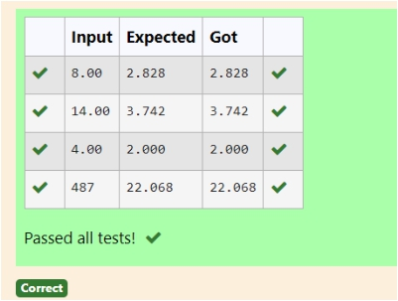

Sample Input:

8.00

Sample Output: 2.828

**For example:**

**Input** **Result**

14.00 3.742

**Department of Computer Science and Engineering** | **Rajalakshmi Engineering College** 12

**Ex. No.** **:** **1.3** **Date:** 12.03.2024

**Register No.:** 230701143 **Name:** KA RTH IKH A SRE M

**Square Root**

Write a simple python program to find the square root of a given floating point number. The output should be displayed with 3 decimal places.

importmath a=float(input()) b=math.sqrt(a) print({':.3f}.'format(b))

**Department of Computer Science and Engineering** | **Rajalakshmi Engineering College** 13

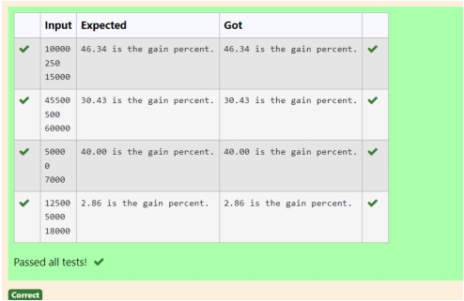

Input Format:

The first line contains the Rs X The second line contains Rs Y The third line contains Rs Z Sample Input:

10000 250 15000

Sample Output:

46.34 is the gain percent.

**For example:**

**Input** **Result**

45500 500 60000

30.43 is the gain percent.

**Department of Computer Science and Engineering** | **Rajalakshmi Engineering College** 14

**Ex. No.** **:** **1.4** **Date:** 12.03.2024

**Register No.:** 230701143 **Name:** KA RTH IKH A SRE M

**Gain percent**

Alfred buys an old scooter for Rs. X and spends Rs. Y on its repairs. If he sells the scooter for Rs. Z (Z>X+Y). Write a program to help Alfred to find his gain percent. Get all the above-mentioned values through the keyboard and find the gain percent.

a=int(input()) b=int(input()) c=int(input()) x=(-a-b)+c y=a+b z=x/y*100

print({':.2f}.'format(z),"isthegainpercent.")

**Department of Computer Science and Engineering** | **Rajalakshmi Engineering College** 15

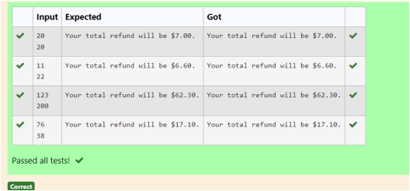

Sample Input

10

20

Sample Output

Your total refund will be $6.00.

**For example:**

**Input** **Result**

20

20

Your total refund will be $7.00.

**Ex. No.** **:** **1.5** **Date:** 12.03.2024

**Department of Computer Science and Engineering** | **Rajalakshmi Engineering College** 16

**Register No.:** 230701143 **Name:** KA RTH IKH A SRE M

**Deposits**

In many jurisdictions, a small deposit is added to drink containers to encourage people to recycle them. In one particular jurisdiction, drink containers holding one liter or less have a $0.10 deposit and drink containers holding more than one liter have a $0.25 deposit. Write a program that reads the number of containers of each size(less and more) from the user. Your program should continue by computing and displaying the refund that will be received for returning those containers. Format the output so that it includes a dollar sign and always displays exactly two decimal places.

a=int(input()) b=int(input()) x=a*0.10 y=b*0.25 z=x+y

print("Yourtotalrefundwilbe

$",{':.2f}.'format(z),.','sep=')

**Department of Computer Science and Engineering** | **Rajalakshmi Engineering College** 17

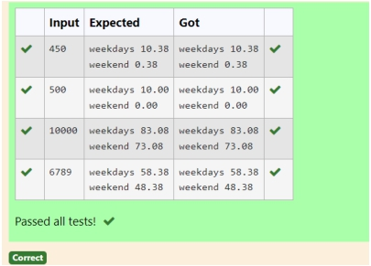

**Sample Input:**

450

**Sample Output:** weekdays 10.38 weekend 0.38

**For example:**

**Input** **Result**

450

weekdays 10.38 weekend 0.38

**Ex. No.** **:** **1.6** **Date:** 12.03.2024

**Department of Computer Science and Engineering** | **Rajalakshmi Engineering College** 18

**Register No.:** 230701143 **Name:** KA RTH IKH A SRE M

**Carpenter**

Justin is a carpenter who works on an hourly basis. He works in a company where he is paid Rs 50 for an hour on weekdays and Rs 80 for an hour on weekends. He works 10 hrs more on weekdays than weekends. If the salary paid for him is given, write a program to find the number of hours he has worked on weekdays and weekends.

**Hint:**

If the final result(hrs) are in -ve convert that to +ve using abs() function The abs() function returns the absolute value of the given number.

number = -20

absolute_number = abs(number)

print(absolute_number)

# Output: 20

a=int(input()) b=abs((a-500)/130) print("weekdays%.2f"%(b+10)) print("weekend%.2f"%b)

**Department of Computer Science and Engineering** | **Rajalakshmi Engineering College** 19

**Department of Computer Science and Engineering** | **Rajalakshmi Engineering College** 20

**02- Operators in Python**

**Department of Computer Science and Engineering** | **Rajalakshmi Engineering College** 21

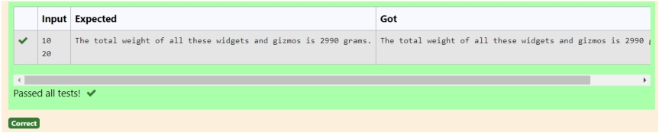

Sample Input

10

20

Sample Output

The total weight of all these widgets and gizmos is 2990 grams. **For example:**

**Input** **Result**

10

20

The total weight of all these widgets and gizmos is 2990 grams.

**Department of Computer Science and Engineering** | **Rajalakshmi Engineering College** 22

**Ex. No.** **:** **2.1** **Date:** 20.03.2024

**Register No.:** 230701143 **Name:** KA RTH IKH A SRE M

**Widgets and Gizmos**

An online retailer sells two products: widgets and gizmos. Each widget weighs

75 grams. Each gizmo weighs 112 grams. Write a program that reads the number of widgets and the number of gizmos from the user. Then your program should compute and display the total weight of the parts.

a=int(input()) b=int(input()) c=a*75 d=b*112

print("Thetotalweightofalthesewidgetsandgizmosis%dgrams."%(c+d))

**Department of Computer Science and Engineering** | **Rajalakshmi Engineering College** 23

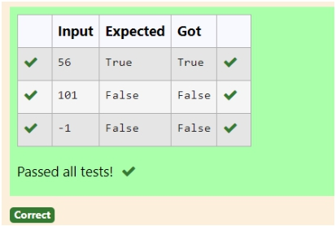

Sample Input

10

Sample Output True Explanation:

Since 10 is an even number and a number between 0 and 100, True is printed

**Ex. No.**

**Register No.:**

**:**

**2.2**

230701143

**Name:**

**Date:** 20.03.2024

KA RTH IKH A SRE M

**Department of Computer Science and Engineering** | **Rajalakshmi Engineering College** 24

**Doll Sings**

In London, every year during Dasara there will be a very grand doll show. People try to invent new dolls of different varieties. The best-sold doll's creator will be awarded with a cash prize. So people broke their heads to create dolls innovatively. Knowing this competition, Mr.Lokpaul tried to create a doll that sings only when an even number is pressed and the number should not be zero and greater than 100.

IF Lokpaul wins print true, otherwise false.

a=int(input()) if((a%2==0)and(a!=0)and(a<100)):

print("True")

else:

print("False")

Input Given: N-No of friends

**Department of Computer Science and Engineering** | **Rajalakshmi Engineering College** 25

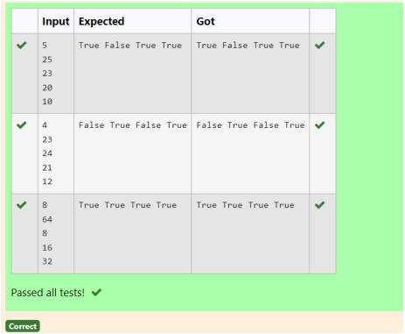

P1,P2,P3 AND P4-No of chocolates

OUTPUT:

"True" if he can buy that packet and "False" if he can't buy that packet.

SAMPLE INPUT AND OUTPUT:

5 25 12 10 9

OUTPUT

True False True False

**Ex. No.** **:** **2.3** **Date:** 20.03.2024

**Register No.:** 230701143 **Name:** KA RTH IKH A SRE M

**Department of Computer Science and Engineering** | **Rajalakshmi Engineering College** 26

**Birthday Party**

Mr. X's birthday is in next month. This time he is planning to invite N of his friends. He wants to distribute some chocolates to all of his friends after the party. He went to a shop to buy a packet of chocolates. At the chocolate shop, 4 packets are there with different numbers of chocolates. He wants to buy such a packet which contains a number of chocolates, which can be distributed equally among all of his friends. Help Mr. X to buy such a packet.

a=int(input()) b=int(input()) c=int(input()) d=int(input()) e=int(input()) if(b%a==0):

f="True"

else: f="False"

if(c%a==0):

g="True"

else:

g="False"

if(d%a==0):

h="True"

else:

h="False" if(e%a==0):

Sample Input

3

Sample Output:

**Department of Computer Science and Engineering** | **Rajalakshmi Engineering College** 27

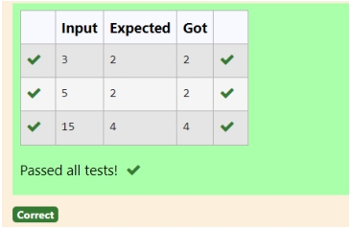

2

Explanation:

The binary representation of 3 is 011, hence there are 2 ones in it. so the output is 2.

**Ex. No.** **:** **2.4** **Date:** 20.03.2024

**Register No.:** 230701143 **Name:** KA RTH IKH A SRE M

**Department of Computer Science and Engineering** | **Rajalakshmi Engineering College** 28

**Hamming Weight**

Write a python program that takes a integer between 0 and 15 as input and displays the number of '1' s in its binary form.(Hint:use python bitwise operator.

a=int(input()) count=bin(a).count('1') print(count)

**Department of Computer Science and Engineering** | **Rajalakshmi Engineering College** 29

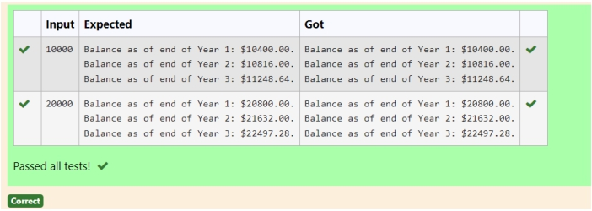

Sample Input:

10000

Sample Output:

Balance as of end of Year 1: $10400.00. Balance as of end of Year 2: $10816.00.

Balance as of end of Year 3: $11248.64

**Department of Computer Science and Engineering** | **Rajalakshmi Engineering College** 30

**Ex. No.** **:** **2.5** **Date:** 20.03.2024

**Register No.:** 230701143 **Name:** KA RTH IKH A SRE M

**Compound Interest**

Pretend that you have just opened a new savings account that earns 4 percent interest per year. The interest that you earn is paid at the end of the year, and is added to the balance of the savings account. Write a program that begins by reading the amount of money deposited into the account from the user. Then your program should compute and display the amount in the savings account after 1, 2, and 3 years. Display each amount so that it is rounded to 2 decimal places.

.

a=int(input()) b=a*(1.04) c=b*(1.04) d=c*(1.04)

print("BalanceasofendofYear1:$%.2f."%b) print("BalanceasofendofYear2:$%.2f."%c) print("BalanceasofendofYear3:$%.2f."%d)

**Department of Computer Science and Engineering** | **Rajalakshmi Engineering College** 31

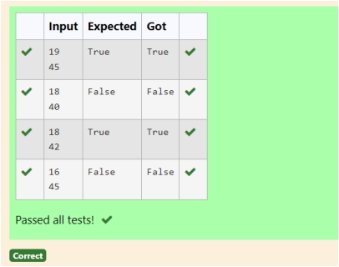

Input Format:

Input consists of two integers that correspond to the age and weight of a person

respectively.

Output Format:

Display True(IF ELIGIBLE) Display False (if not eligible) Sample Input

19

45

Sample Output True

**Department of Computer Science and Engineering** | **Rajalakshmi Engineering College** 32

**Ex. No.** **:** **2.6** **Date:** 20.03.2024

**Register No.:** 230701143 **Name:** KA RTH IKH A SRE M

**Eligible to donate blood**

A team from the Rotract club had planned to conduct a rally to create awareness among the Coimbatore people to donate blood. They conducted the rally successfully. Many of the Coimbatore people realized it and came forward to donate their blood to nearby blood banks. The eligibility criteria for donating blood are people should be above or equal to 18 and his/ her weight should be above 40. There was a huge crowd and staff in the blood bank found it difficult to manage the crowd. So they decided to keep a system and ask the people to enter their age and weight in the system. If a person is eligible he/she will be allowed inside.

Write a program and feed it to the system to find whether a person is eligible or not.

a=int(input()) b=int(input())

c=(print("True"))if((a>=18)and(b>40)) else(print("False"))

**Department of Computer Science and Engineering** | **Rajalakshmi Engineering College** 33

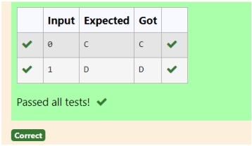

**Input Format:**

An integer x, 0<=x<=1. . **Output Format:**

output a single character "C" or "D"depending on the value of x.

**Input 1:**

0

**Output 1:** C

**Input 2:** 1

**Output 1:** D

**Department of Computer Science and Engineering** | **Rajalakshmi Engineering College** 34

**Ex. No.** **:** **2.7** **Date:** 20.03.2024

**Register No.:** 230701143 **Name:** KA RTH IKH A SRE M

**C or D**

Mr.Ram has been given a problem kindly help him to solve it. The input of the program is either 0 or 1. IF 0 is the input he should display "C" if 1 is the input it should display "D".There is a constraint that Mr. Ram should use either logical operators or arithmetic operators to solve the problem, not anything else.

Hint:

Use ASCII values of C and D.

a=int(input()) if(a==0):

print("C")

else:

print("D")

**Department of Computer Science and Engineering** | **Rajalakshmi Engineering College** 35

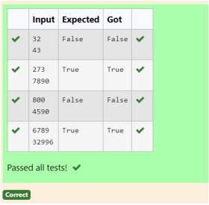

**Input format:**

Line 1 has the total number of weapons Line 2 has the total number of Soldiers. **Output Format:**

If the battle can be won print True otherwise print False.

Sample Input:

32

43

Sample Output:' False

**Department of Computer Science and Engineering** | **Rajalakshmi Engineering College** 36

**Ex. No.** **:** **2.8** **Date:** 20.03.2024

**Register No.:** 230701143 **Name:** KA RTH IKH A SRE M

**Troy Battle**

In the 1800s, the battle of Troy was led by Hercules. He was a superstitious person. He believed that his crew can win the battle only if the total count of the weapons in hand is in multiple of 3 and the soldiers are in an even number of count. Given the total number of weapons and the soldier's count, Find whether the battle can be won or not according to Hercules's belief. If the battle can be won print True otherwise print False.

a=int(input()) b=int(input()) if((a%3==0)and(b%2==0)):

print("True")

else:

print("False")

**Department of Computer Science and Engineering** | **Rajalakshmi Engineering College** 37

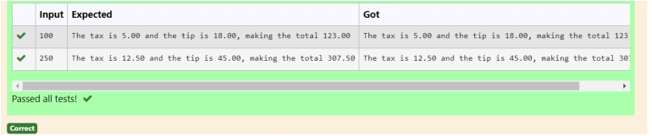

Sample Input

100

Sample Output

The tax is 5.00 and the tip is 18.00, making the total 123.00

**Department of Computer Science and Engineering** | **Rajalakshmi Engineering College** 38

**Department of Computer Science and Engineering** | **Rajalakshmi Engineering College** 39

**Ex. No. Register No.:**

**:**

**2.9**

230701143

**Name:**

**Date:** 20.03.2024

KA RTH IKH A SRE M

**Tax and Tip**

The program that you create for this exercise will begin by reading the cost of a meal ordered at a restaurant from the user. Then your program will compute the tax and tip for the meal. Use your local tax rate (5 percent) when computing the amount of tax owing. Compute the tip as 18 percent of the meal amount (without the tax). The output from your program should include the tax amount, the tip amount, and the grand total for the meal including both the tax and the tip. Format the output so that all of the values are displayed using two decimal places.

a=float(input()) b=a*0.05 c=a*0.18 d=a+b+c

print("Thetaxis%.2fandthetipis%.2f,making thetotal%.2f"%(b,c,d))

**Department of Computer Science and Engineering** | **Rajalakshmi Engineering College** 40

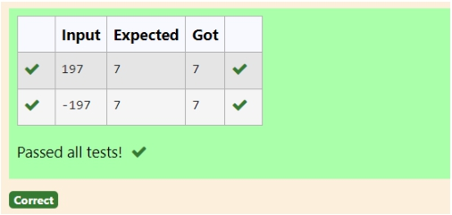

**For example:**

**Input** **Result**

123 3

**Department of Computer Science and Engineering** | **Rajalakshmi Engineering College** 41

**Ex. No. Register No.:**

**:**

**2.10**

230701143

**Name:**

**Date:** 20.03.2024

KA RTH IKH A SRE M

**Return last digit of the given number**

Write a program that returns the last digit of the given number. Last digit is being referred to the least significant digit i.e. the digit in the ones (units) place in the given number.

The last digit should be returned as a positive number.

For example,

if the given number is 197, the last digit is 7 if the given number is -197, the last digit is 7

a=int(input()) if(a<0):

a=a*-1; b=a%10;

else:

b=a%10

print(b)

**Department of Computer Science and Engineering** | **Rajalakshmi Engineering College** 42

**Department of Computer Science and Engineering** | **Rajalakshmi Engineering College** 43

**03 - Selection Structures in Python**

**Department of Computer Science and Engineering** | **Rajalakshmi Engineering College** 44

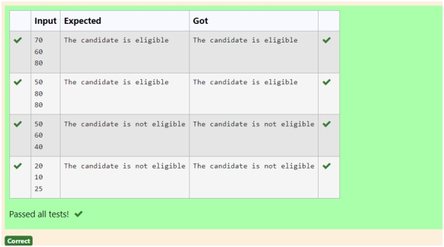

Sample Test Cases

Test Case 1

Input

70 60 80

Output

The candidate is eligible

Test Case 2

Input

50 80 80

Output

The candidate is eligible

Test Case 3

Input

50 60 40

Output

The candidate is not eligible

**For example:**

**Input** **Result**

50 80 80

The candidate is eligible

**Department of Computer Science and Engineering** | **Rajalakshmi Engineering College** 45

**Ex. No. Register No.:**

**:**

**3.1**

230701143

**Name:**

**Date:** 28.03.2024

KA RTH IKH A SRE M

**Admission Eligibility**

Write a program to find the eligibility of admission for a professional course based on the following criteria:

Marks in Maths >= 65 Marks in Physics >= 55 Marks in Chemistry >= 50 Or

Total in all three subjects >= 180

m=int(input()) p=int(input()) c=int(input())

d=(m>=65)and(p>=55)and(c>=50)

e=m+p+c

if(dore>=180):

print("Thecandidateiseligible")

else:

print("Thecandidateisnoteligible")

**Department of Computer Science and Engineering** | **Rajalakshmi Engineering College** 46

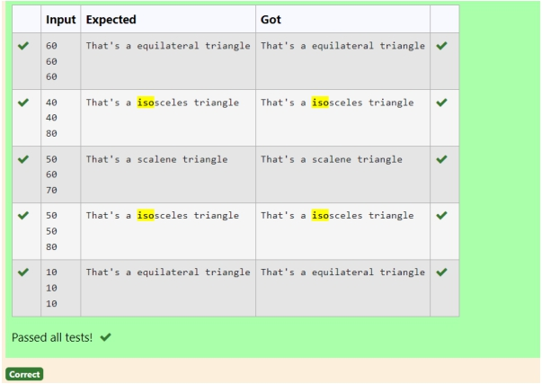

Sample Input 1 60

60

60

Sample Output 1

That's a equilateral triangle

**For example:**

**Input** **Result**

40 40 80

That's a isosceles triangle

**Department of Computer Science and Engineering** | **Rajalakshmi Engineering College** 47

**Ex. No. Register No.:**

**:**

**3.2**

230701143

**Name:**

**Date:** 28.03.2024

KA RTH IKH A SRE M

**Classifying Triangles**

A triangle can be classified based on the lengths of its sides as equilateral, isosceles or scalene. All three sides of an equilateral triangle have the same length. An isosceles triangle has two sides that are the same length, and a third side that is a different length. If all of the sides have different lengths then the triangle is scalene.

Write a program that reads the lengths of the three sides of a triangle from the user. Then display a message that states the triangle’s type.

a=int(input()) b=int(input()) c=int(input()) if(a==b==c):

print("That'saequilateraltriangle")

elif((a==b)and(a!=c)):

print("That'saisoscelestriangle")

elif((b==c)and(b!=a)):

print("That'saisoscelestriangle")

elif((c==a)and(b!=c)):

print("That'saisoscelestriangle")

else:

print("That'sascalenetriangle")

**Department of Computer Science and Engineering** | **Rajalakshmi Engineering College** 48

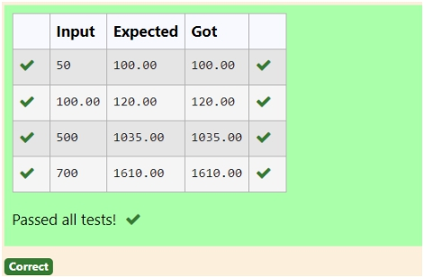

Sample Test Cases

Test Case 1

Input 50 Output 100.00

Test Case 2

Input 300 Output 517.50

**For example:**

**Input** **Result**

500 1035.00

**Department of Computer Science and Engineering** | **Rajalakshmi Engineering College** 49

**Ex. No.** **:** **3.3** **Date:** 28.03.2024

**Register No.:** 230701143 **Name:** KA RTH IKH A SRE M

**Electricity Bill**

Write a program to calculate and print the Electricity bill where the unit consumed by the user is given from test case. It prints the total amount the customer has to pay. The charge are as follows:

Unit Charge / Unit

Upto 199 @1.20

200 and above but less than 400 @1.50

400 and above but less than 600 @1.80

600 and above @2.00

If bill exceeds Rs.400 then a surcharge of 15% will be charged and the minimum bill should be of Rs.100/-

a=float(input())

if (a<=199):

bill=a*1.20

elif (a>=200 and a<400):

bill=a*1.50

elif (a>=400 and a<600):

bill=a*1.80

else:

bill=a*2.00 if (bill>400):

bill+=bill*0.15

elif (bill<100):

bill=100

print("% .2f"% bill)

**Department of Computer Science and Engineering** | **Rajalakshmi Engineering College** 50

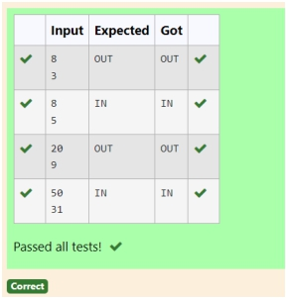

Input Format:

Input consists of 2 integers.

The first integer corresponds to the number of problems given and the second integer

corresponds to the number of problems solved.

Output Format:

Output consists of the string “IN” or “OUT”.

Sample Input and Output: Input

8

3 Output OUT

**For example:**

**Input** **Result**

8

3

OUT

**Department of Computer Science and Engineering** | **Rajalakshmi Engineering College** 51

**Ex. No.** **:** **3.4** **Date:** 28.03.2024

**Register No.:** 230701143 **Name:** KA RTH IKH A SRE M

**IN/OUT**

Ms. Sita, the faculty handling programming lab for you is very strict. Your seniors have told you that she will not allow you to enter the week's lab if you have not completed atleast half the number of problems given last week. Many of you didn't understand this statement and so they requested the good programmers from your batch to write a program to find whether a student will be allowed into a week's lab given the number of problems given last week and the number of problems solved by the student in that week.

a=int(input()) b=int(input()) if(b<(a/2)):

print("O U T")

else:

print("IN ")

**Department of Computer Science and Engineering** | **Rajalakshmi Engineering College** 52

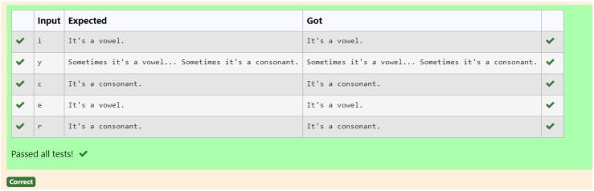

Sample Input 1 i

Sample Output 1 It's a vowel. Sample Input 2

y

Sample Output 2

Sometimes it's a vowel... Sometimes it's a consonant. Sample Input3

c

Sample Output 3 It's a consonant.

**For example:**

**Input** **Result**

y Sometimes it's a vowel... Sometimes it's a consonant.

u It's a vowel.

p It's a consonant.

**Department of Computer Science and Engineering** | **Rajalakshmi Engineering College** 53

**Ex. No. Register No.:**

**:**

**3.5**

230701143

**Name:**

**Date:** 28.03.2024

KA RTH IKH A SRE M

**Vowel or Consonant**

In this exercise you will create a program that reads a letter of the alphabet from the user. If the user enters a, e, i, o or u then your program should display a message indicating that the entered letter is a vowel. If the user enters 'y' then your program should display a message indicating that sometimes y is a vowel, and sometimes y is a consonant. Otherwise your program should display a message indicating that the letter is a consonant.

var=input()

if(var=='a'or var=='e'or var=='i'or var=='o'or var=='u'):

print("It's a vow el.")

elif(var=='y'):

print("Som etim es it's a vow el... Som etim es it's a consonant.")

else:

print("It's a consonant.")

**Department of Computer Science and Engineering** | **Rajalakshmi Engineering College** 54

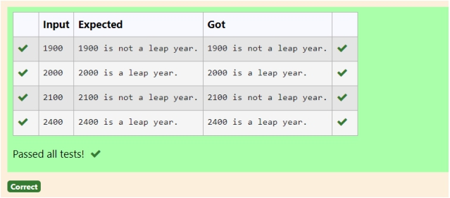

Sample Input 1 1900

Sample Output 1

1900 is not a leap year. Sample Input 2

2000

Sample Output 2 2000 is a leap year.

**Department of Computer Science and Engineering** | **Rajalakshmi Engineering College** 55

**Ex. No.** **:** **3.6** **Date:** 28.03.2024

**Register No.:** 230701143 **Name:** KA RTH IKH A SRE M

**Leap Year**

Most years have 365 days. However, the time required for the Earth to orbit the Sun is actually slightly more than that. As a result, an [extra](https://www.rajalakshmicolleges.net/moodle/mod/quiz/view.php?id=5753) day, February 29, is included in some years to correct for this difference. Such years are referred to as leap years. The rules for determining whether or not a year is a leap year follow:

• Any year that is divisible by 400 is a leap year.

• Of the remaining years, any year that is divisible by 100 is not a leap year.

• Of the remaining years, any year that is divisible by 4 is a leap year.

• All other years are not leap years.

Write a program that reads a year from the user and displays a message indicating whether or not it is a leap year.

y=int(input()) if (y% 400==0):

print(f"{y} is a leap year.")

elif (y% 100==0):

print(f"{y} is not a leap year.")

elif (y% 4==0):

print(f"{y} is a leap year.")

else:

print(f"{y} is not a leap year.")

**Department of Computer Science and Engineering** | **Rajalakshmi Engineering College** 56

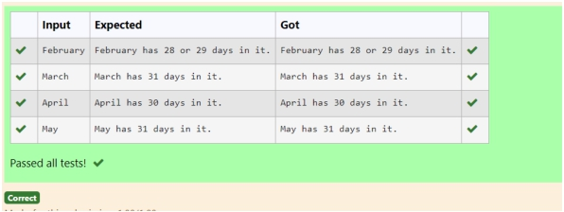

Sample Input 1

February

Sample Output 1

February has 28 or 29 days in it.

Sample Input 2

March

Sample Output 2

March has 31 days in it.

Sample Input 3

April

Sample Output 3

April has 30 days in it.

**For example:**

**Input** **Result**

February February has 28 or 29 days in it.

March March has 31 days in it.

**Department of Computer Science and Engineering** | **Rajalakshmi Engineering College** 57

**Ex. No.** **:** **3.7** **Date:** 28.03.2024

**Register No.:** 230701143 **Name:** KA RTH IKH A SRE M

**Month name to days**

The length of a month varies from 28 to 31 days. In this exercise you will create a program that reads the name of a month from the user as a string. Then your program should display the number of days in that month. Display “28 or 29 days” for February so that leap years are addressed.

m =input().capitalize()

if m =="January"or m =="M arch"or m =="M ay"or m =="July"or

m =="A ugust"or m =="O ctuber"or m =="D ecem ber":

d=31

elif m =="A pril"or m =="June"or m =="Septem ber"or m =="N ovem ber":

d=30

elif m =="February":

d="28 or 29"

else:

d=N one if d:

print(f"{m } has {d} days in it.")

**Department of Computer Science and Engineering** | **Rajalakshmi Engineering College** 58

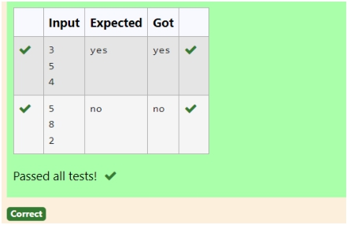

**Sample Input** 3

5

4

**Sample Output** Yes

**For example: Input** **Result**

3 4 5

Yes

**Department of Computer Science and Engineering** | **Rajalakshmi Engineering College** 59

**Ex. No.** **:** **3.8** **Date:** 28.03.2024

**Register No.:** 230701143 **Name:** KA RTH IKH A SRE M

**Pythagorean triple**

Three numbers form a Pythagorean triple if the [sum](https://www.rajalakshmicolleges.net/moodle/mod/quiz/view.php?id=5759) [of](https://www.rajalakshmicolleges.net/moodle/mod/quiz/view.php?id=5759) [squares](https://www.rajalakshmicolleges.net/moodle/mod/quiz/view.php?id=5759) of two numbers is equal to the square of the third.

For example, 3, 5 and 4 form a Pythagorean triple, since 3*3 + 4*4 = 25 = 5*5 You are given three integers, a, b, and c. They need not be given in increasing order. If they form a Pythagorean triple, then print "Yes", otherwise, print "No".

a=int(input()) b=int(input()) c=int(input()) d=(a*a)+(b*b) e=(b*b)+(c*c) f=(c*c)+(a*a)

if(d==(c*c) or e==(a*a) or f==(b*b)):

print("yes")

else:

print("no")

**Department of Computer Science and Engineering** | **Rajalakshmi Engineering College** 60

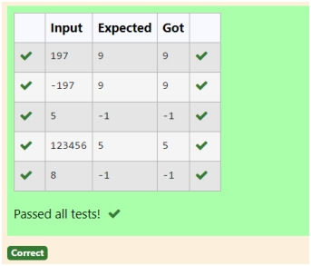

**For example:**

**Input** **Result**

197 9

**Department of Computer Science and Engineering** | **Rajalakshmi Engineering College** 61

**Ex. No.** **:** **3.9** **Date:** 28.03.2024

**Register No.:** 230701143 **Name:** KA RTH IKH A SRE M

**Second last digit**

Write a program that returns the second last digit of the given number. Second last digit is being referred 10the digit in the tens place in the given number.

For example, if the given number is 197, the second last digit is 9.

Note1 - The second last digit should be returned as a positive number. i.e. if the given number is -197, the second last digit is 9.

Note2 - If the given number is a single digit number, then the second last digit does not exist. In such cases, the program should return -1. i.e. if the given number is 5, the second last digit should be returned as -1.

a=int(input()) a=abs(a) nstr=str(a)

if len(nstr)<2:

second=-1

else:

second=int(nstr[-2])

print(second)

**Department of Computer Science and Engineering** | **Rajalakshmi Engineering College** 62

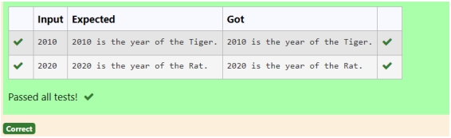

Sample Input 1 2010

Sample Output 1

2010 is the year of the Tiger. Sample Input 2

2020

Sample Output 2

2020 is the year of the Rat.

**Department of Computer Science and Engineering** | **Rajalakshmi Engineering College** 63

**Ex. No. Register No.:**

**:**

**3.10**

230701143

**Name:**

**Date:** 28.03.2024

KA RTH IKH A SRE M

**Chinese Zodiac**

The Chinese zodiac assigns animals to years in a 12 year cycle. One 12 year cycle is shown in the table below. The pattern repeats from there, with 2012 being another year of the dragon, and 1999 being another year of the hare.

Year Animal 2000 Dragon 2001 Snake 2002 Horse 2003 Sheep 2004 Monkey 2005 Rooster 2006 Dog 2007 Pig 2008 Rat 2009 Ox

2010 Tiger

2011 Hare

Write a program that reads a year from the user and displays the animal associated with that year. Your program should work correctly for any year greater than or equal to zero, not just the ones listed in the table.

y=int(input()) r=y% 12

if r==0:

a="M onkey"

elif r==1:

a="Rooster"

elif r==2:

a="D og"

elif r==3:

a="Pig"

**Department of Computer Science and Engineering** | **Rajalakshmi Engineering College** 64

elif r==4:

a="Rat"

elif r==5:

a="O x"

elif r==6:

a="Tiger"

elif r==7:

a="H are"

elif r==8:

a="D ragon"

elif r==9:

a="Snake"

elif r==10:

a="H orse"

elif r==11:

a="Sheep"

print(f"{y} is the year of the {a}.")

**Department of Computer Science and Engineering** | **Rajalakshmi Engineering College** 65

**Department of Computer Science and Engineering** | **Rajalakshmi Engineering College** 66

**Department of Computer Science and Engineering** | **Rajalakshmi Engineering College** 67

**04 - Iteration Control Structures**

**Department of Computer Science and Engineering** | **Rajalakshmi Engineering College** 68

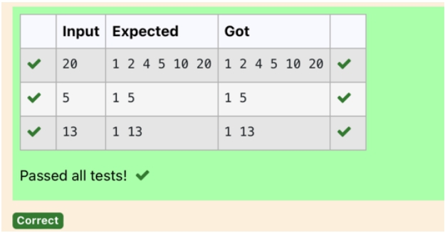

**For example:**

**Input** **Result**

20 1 2 4 5 10 20

**Department of Computer Science and Engineering** | **Rajalakshmi Engineering College** 69

**Ex. No.** **:** **4.1** **Date:** 01.05.2024

**Register No.:** 230701143 **Name:** KA RTH IKH A SRE M

**Factors of a number**

Determine the factors of a number (i.e., all positive integer values that evenly divide into a number).

k=int(input()) l=[]

for iin range(1,k+1):

if(k% i==0): l.append(i)

for jin l:

print(j,end='')

**Department of Computer Science and Engineering** | **Rajalakshmi Engineering College** 70

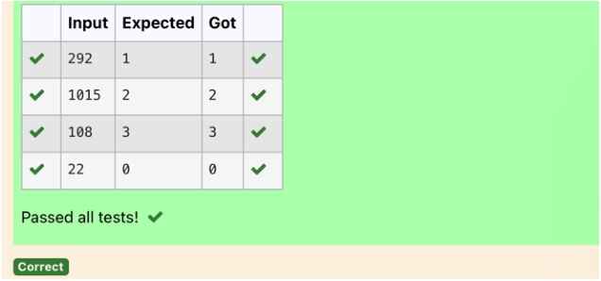

**For example:**

**Input** **Result**

292 1

1015 2

108 3

22 0

**Department of Computer Science and Engineering** | **Rajalakshmi Engineering College** 71

**Ex. No. Register No.:**

**:**

**4.2**

230701143

**Name:**

**Date:** 01.05.2024

KA RTH IKH A SRE M

I n s e r

**Non Repeated Digit Count**

Write a program to find the count of non-repeated digits in a given number N. The number will be passed to the program as an input of type int.

Assumption: The input number will be a positive integer number >= 1 and <= 25000.

Some examples are as below.

If the given number is 292, the program should return 1 because there is only 1 non- repeated digit '9' in this number

If the given number is 1015, the program should return 2 because there are 2 non- repeated digits in this number, '0', and '5'.

If the given number is 108, the program should return 3 because there are 3 non- repeated digits in this number, '1', '0', and '8'.

If the given number is 22, the function should return 0 because there are NO non- repeated digits in this number.

n=int(input()) l=[]

k=[]

w hile n>0: a=n% 10 n=n//10 l.append(a)

for iin range(len(l)):

if l.count(l[i])==1:

k.append(l[i])

print(len(k))

t t e x t h e r e

**Department of Computer Science and Engineering** | **Rajalakshmi Engineering College** 72

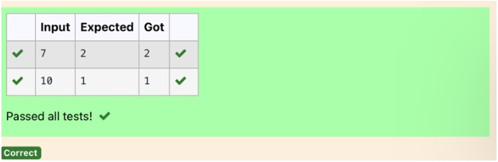

Example1: if the given number N is 7, the method must return 2 Example2: if the given number N is 10, the method must return 1

**For example:**

**Input** **Result**

7 2

10 1

**Department of Computer Science and Engineering** | **Rajalakshmi Engineering College** 73

**Ex. No. Register No.:**

**:**

**4.3**

230701143

**Name:**

**Date:** 01.05.2024

KA RTH IKH A SRE M

**Prime Checking**

Write a program that finds whether the given number N is Prime or not. If the number is prime, the program should return 2 else it must return 1.

Assumption: 2 <= N <=5000, where N is the given number.

a=int(input())

for iin range(2,a):

if(a% 2==0):

flag=0

elif(a% i!=0):

flag=1

else:

flag=0

if(flag==1):

print("2")

elif(flag==0):

print("1")

**Department of Computer Science and Engineering** | **Rajalakshmi Engineering College** 74

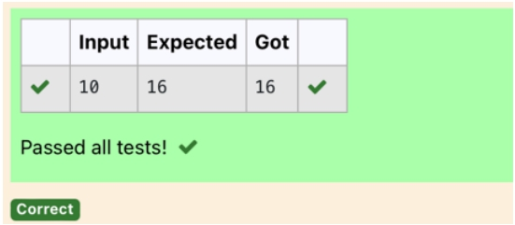

Input Format:

Integer input from stdin. Output Format:

Perfect square greater than N. Example Input:

10 Output: 16

**Department of Computer Science and Engineering** | **Rajalakshmi Engineering College** 75

**Ex. No.** **:** **4.4** **Date:** 01.05.2024

**Register No.:** 230701143 **Name:** KA RTH IKH A SRE M

**Next Perfect Square**

Given a number N, find the next perfect square greater than N.

a=int(input())

c=[]

for iin range(0,a):

b=i**2

if(b>a):

c.append(b)

print(c[0])

**Department of Computer Science and Engineering** | **Rajalakshmi Engineering College** 76

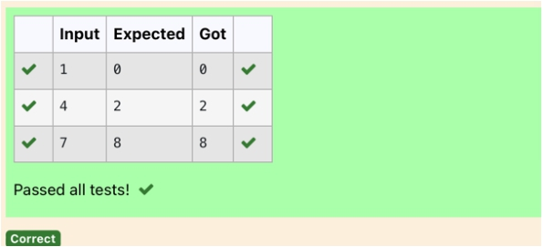

NOTE: Fibonacci series looks like –

0, 1, 1, 2, 3, 5, 8, 13, 21, 34, 55, . . . and so on.

i.e. Fibonacci series starts with 0 and 1, and continues generating the next number as the sum of the previous two numbers.

• first Fibonacci number is 0,

• second Fibonacci number is 1,

• third Fibonacci number is 1,

• fourth Fibonacci number is 2,

• fifth Fibonacci number is 3,

• sixth Fibonacci number is 5,

• seventh Fibonacci number is 8, and so on.

**For example:**

**Input:**

**7 Output 8**

**Department of Computer Science and Engineering** | **Rajalakshmi Engineering College** 77

**Ex. No.** **:** **4.5** **Date:** 01.05.2024

**Register No.:** 230701143 **Name:** KA RTH IKH A SRE M

**Nth Fibonacci**

Write a [program](https://www.rajalakshmicolleges.net/moodle/mod/quiz/view.php?id=3478) to return the nth number in the fibonacci series. The value of N will be passed to the [program](https://www.rajalakshmicolleges.net/moodle/mod/quiz/view.php?id=3478) as input.

a=[0,1]

for iin range(0,100):

a.append(a[-1]+a[-2]) q=int(input()) print(a[q- 1])

**Department of Computer Science and Engineering** | **Rajalakshmi Engineering College** 78

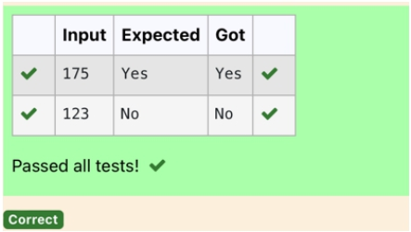

Input Format:

Single Integer Input from stdin. Output Format:

Yes or No. Example Input: 175

Output:

Yes

Explanation

1^1 + 7^2 +5^3 = 175 Example Input:

123 Output: No

**For example:**

**Input Result**

175 Yes

123 No

**Department of Computer Science and Engineering** | **Rajalakshmi Engineering College** 79

**Ex. No.** **:** **4.6** **Date:** 01.05.2024

**Register No.:** 230701143 **Name:** KA RTH IKH A SRE M

**Disarium Number**

A Number is said to be Disarium number when the sum of its digit raised to the power of their respective positions becomes equal to the number itself. Write a [program](https://www.rajalakshmicolleges.net/moodle/mod/quiz/view.php?id=3478) to print number is Disarium or not.

n=int(input()) a=len(str(n)) sum =0

x=n

w hile(x!=0):

r=x% 10

sum =int(sum +m ath.pow (r,a))

a-=1

x=x//10

if(sum ==n):

print("Yes")

else:

print("N o")

**Department of Computer Science and Engineering** | **Rajalakshmi Engineering College** 80

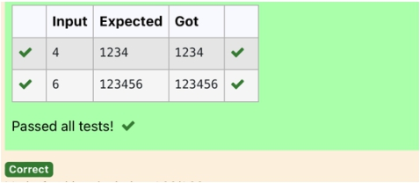

Sample Test Cases

Test Case 1

Input

4 Output 1234

Explanation:

as input is 4, have to take 4 terms.

1 + 11 + 111 + 1111

Test Case 2

Input

6 Output 123456

**For example:**

**Input** **Result**

3 123

**Department of Computer Science and Engineering** | **Rajalakshmi Engineering College** 81

**Ex. No.** **:** **4.7** **Date:** 01.05.2024

**Register No.:** 230701143 **Name:** KA RTH IKH A SRE M

**Sum of Series**

Write a program to find the sum of the series 1 +11 + 111 + 1111 + . . . + n terms (n will be given as input from the user and sum will be the output)

n=int(input()) b=1

sum =0

for iin range(1,n+1):

sum +=b b=(b*10)+1

print(sum )

**Department of Computer Science and Engineering** | **Rajalakshmi Engineering College** 82

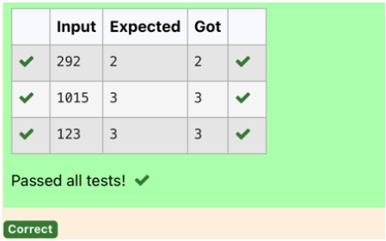

**For example:**

**Input** **Result**

292 2

1015 3

**Department of Computer Science and Engineering** | **Rajalakshmi Engineering College** 83

**Ex. No. Register No.:**

**:**

**4.8**

230701143

**Name:**

**Date:** 01.05.2024

KA RTH IKH A SRE M

**Unique Digit Count**

Write a program to find the count of unique digits in a given number N. The number will be passed to the program as an input of type int.

Assumption: The input number will be a positive integer number >= 1 and <= 25000.

For e.g.

If the given number is 292, the program should return 2 because there are only 2 unique digits '2' and '9' in this number

If the given number is 1015, the program should return 3 because there are 3 unique digits in this number, '1', '0', and '5'.

a=int(input()) b=[]

w hile a>0: c=a% 10 a=a//10 b.append(c)

b=list(set(b)) print(len(b))

**Department of Computer Science and Engineering** | **Rajalakshmi Engineering College** 84

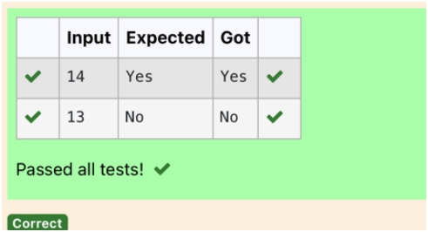

Input Format:

Single Integer input. Output Format:

Output displays Yes if condition satisfies else prints No. Example Input:

14 Output: Yes

Example Input:

13 Output: No

**Department of Computer Science and Engineering** | **Rajalakshmi Engineering College** 85

**Ex. No.** **:** **4.9** **Date:** 01.05.2024

**Register No.:** 230701143 **Name:** KA RTH IKH A SRE M

**Product of single digit**

Given a positive integer N, check whether it can be represented as a product of single digit numbers.

a=int(input())

flag=0

for iin range(10):

for jin range(10): if(i*j==a):

flag=1

break

if(flag==1):

print("Yes")

else:

print("N o")

**Department of Computer Science and Engineering** | **Rajalakshmi Engineering College** 86

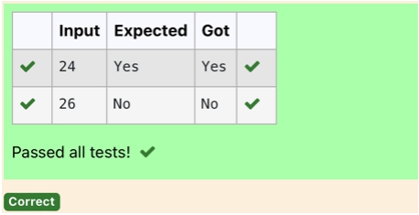

Input Format: Single integer input. Output Format:

Yes or No. Example Input: 24

Output:

Yes

Example Input:

26 Output: No

**For example:**

**Input** **Result**

24 Yes

**Department of Computer Science and Engineering** | **Rajalakshmi Engineering College** 87

**Ex. No.** **:** **4.10** **Date:** 01.05.2024

**Register No.:** 230701143 **Name:** KA RTH IKH A SRE M

**Perfect Square After adding One**

Given an integer N, check whether N the given number can be made a perfect square after adding 1 to it.

im port m ath n=int(input()) a=n+1

sr=int(m ath.sqrt(a)) if(sr*sr==a):

print("Yes")

else:

print("N o")

**Department of Computer Science and Engineering** | **Rajalakshmi Engineering College** 88

**Department of Computer Science and Engineering** | **Rajalakshmi Engineering College** 89

**05 - List in Python**

**Department of Computer Science and Engineering** | **Rajalakshmi Engineering College** 90

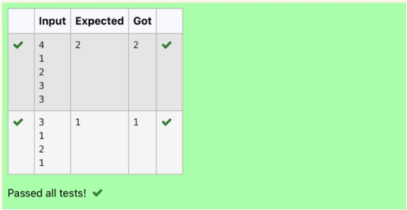

Sample Case 0 Sample Input 0 4

1 2 3 3

Sample Output 0 2

Explanation 0

· The sum of the first two elements, 1+2=3. The value of the last element is

3.

·

Using zero based indexing, arr[2]=3 is the pivot between the two

subarrays.

· The index of the pivot is 2.

Sample Case 1 Sample Input 1 3

1 2 1

Sample Output 1

1

Explanation 1

· The first and last elements are equal to 1.

· Using zero based indexing, arr[1]=2 is the pivot between the two

subarrays.

· The index of the pivot is 1.

**For example:**

**Input** **Result**

4 1 2 3 3

2

3 1 2 1

1

**Department of Computer Science and Engineering** | **Rajalakshmi Engineering College** 91

**Ex. No. Register No.:**

**:**

**5.1**

230701143

**Name:**

**Date:** 03.05.2024

KA RTH IKH A SRE M

**Balanced Array**

Given an array of numbers, find the index of the smallest array element (the pivot), for which the sums of all elements to the left and to the right are equal. The array may not be reordered.

Example

arr=[1,2,3,4,6]

· the sum of the first three elements, 1+2+3=6. The value of the last element is 6.

· Using zero based indexing, arr[3]=4 is the pivot between the two subarrays.

· The index of the pivot is 3.

Constraints

· 3 ≤ n ≤ 105

· 1 ≤ arr[i] ≤ 2 × 104, where 0 ≤ i < n

· It is guaranteed that a solution always exists.

The first line contains an integer n, the size of the array arr.

Each of the next n lines contains an integer, arr[i], where 0 ≤ i < n.

a=int(input()) l=[]

for iin range(a): c=int(input()) l.append(c)

for iin range(1,a): d=sum (l[0:i]) r=sum (l[i+1:]) if(d==r):

print(i)

**Department of Computer Science and Engineering** | **Rajalakshmi Engineering College** 92

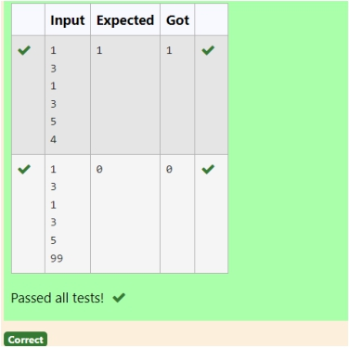

Input

1 3 1 3 5 4

Output:

1 Input 1

3 1 3 5

99 Output 0

**For example:**

**Input** **Result**

1 3 1 3 5 4

1

1 3 1 3 5 99

0

**Department of Computer Science and Engineering** | **Rajalakshmi Engineering College** 93

**Ex. No. Register No.:**

**:**

**5.2**

230701143

**Name:**

**Date:** 03.05.2024

KA RTH IKH A SRE M

**Check pair with difference k**

Given an array A of sorted integers and another non negative integer k, find if there exists 2 indices i and j such that A[i] - A[j] = k, i != j.

Input Format

1. First line is number of test cases T. Following T lines contain:

2. N, followed by N integers of the array

3. The non-negative integer k

Output format

Print 1 if such a pair exists and 0 if it doesn’t.

a=int(input())

for _ in range(a):

l=[] s=0

n = int(input()) for _ in range(n):

l.append(int(input()))

k=int(input()) for iin range(n):

for jin range(i+1,n): if l[j]-l[i]==k and i!=j:

s=1

break

if(s):

break

print(s)

**Department of Computer Science and Engineering** | **Rajalakshmi Engineering College** 94

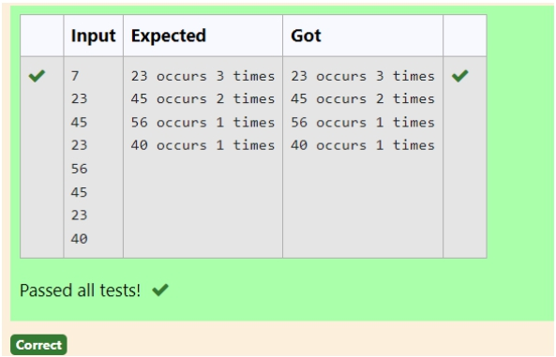

Sample Test Cases

Test Case 1

Input

7 23 45 23 56 45 23 40

Output

23 occurs 3 times

45 occurs 2 times

56 occurs 1 times

40 occurs 1 times

**Department of Computer Science and Engineering** | **Rajalakshmi Engineering College** 95

**Ex. No. Register No.:**

**:**

**5.3**

230701143

**Name:**

**Date:** 03.05.2024

KA RTH IKH A SRE M

**Count Elements**

Complete the program to count frequency of each element of an array. Frequency of a particular element will be printed once.

a=int(input()) dic={}

for iin range(a):

k=int(input()) if k not in dic:

dic[k]=1

else:

dic[k]+=1 for iin dic:

print(f"{i} occurs {dic[i]} tim es")

**Department of Computer Science and Engineering** | **Rajalakshmi Engineering College** 96

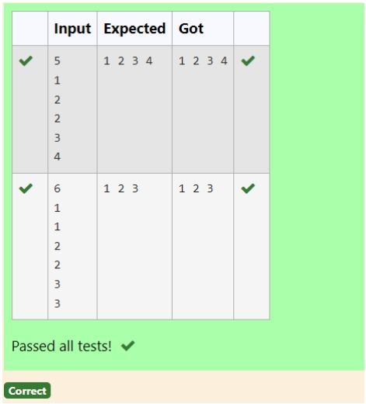

Example Input: 5

1 2 2 3 4

Output:

1 2 3 4

Example Input: 6

1 1 2 2 3 3

Output:

1 2 3

For example: Input Result 5

1 2 2 3 4

1 2 3 4

6 1 1 2 2 3 3

1 2 3

**Department of Computer Science and Engineering** | **Rajalakshmi Engineering College** 97

**Ex. No. Register No.:**

**:**

**5.4**

230701143

**Name:**

**Date:** 03.05.2024

KA RTH IKH A SRE M

**Distinct Elements in an Array**

Program to print all the distinct elements in an array. Distinct elements are nothing

but the unique (non-duplicate) elements present in the given array.

Input Format:

First line take an Integer input from stdin which is array length n.

Second line take n Integers which is inputs of array. Output Format:

Print the Distinct Elements in Array in single line which is space Separated

a=set() b=int(input()) for iin range(b):

a.add(int(input())) b=sorted(list(a)) for iin b:

print(i,end='')

**Department of Computer Science and Engineering** | **Rajalakshmi Engineering College** 98

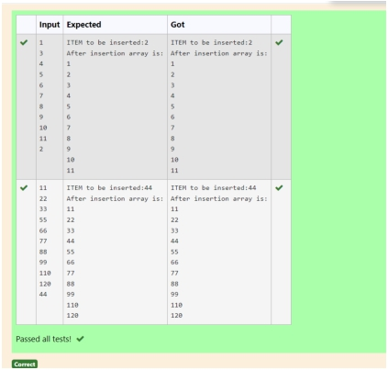

Sample Test Cases

Test Case 1 Input

1 3 4 5 6 7 8 9

10 11 2

Output

ITEM to be inserted:2 After insertion array is: 1

2 3 4 5 6 7 8 9

10

11

Test Case 2 Input

11 22 33 55 66 77 88 99 110 120 44

Output

ITEM to be inserted:44 After insertion array is: 11

22 33 44 55 66 77 88 99 110 120

**Department of Computer Science and Engineering** | **Rajalakshmi Engineering College** 99

**Ex. No. Register No.:**

**:**

**5.5**

230701143

**Name:**

**Date:** 03.05.2024

KA RTH IKH A SRE M

**Element Insertion**

Consider a program to insert an element / item in the sorted array. Complete the logic by filling up required code in editable section. Consider an array of size 10. The eleventh item is the data is to be inserted.

l=[]

for iin range(10):

l.append(int(input())) c=int(input()) l.append(c)

l=sorted(l)

print(f"ITEM to be inserted:{c}\nA fter insertion

array is:") for iin l:

print(i)

**Department of Computer Science and Engineering** | **Rajalakshmi Engineering College** 100

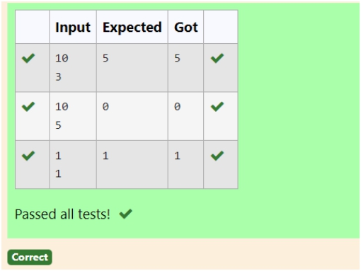

**Sample Case 0 Sample Input 0** 10

3

**Sample Output 0**

5

**Explanation 0**

Factoring n = 10 results in {1, 2, 5, 10}. Return the p = 3rd factor, 5, as the

answer. **Sample Case 1 Sample Input 1** 10

5

**Sample Output 1**

0

**Explanation 1**

Factoring n = 10 results in {1, 2, 5, 10}. There are only 4 factors and p = 5, therefore 0 is returned as the answer.

**Sample Case 2 Sample Input 2** 1

1

**Sample Output 2**

1

**Explanation 2**

Factoring n = 1 results in {1}. The p = 1st factor of 1 is returned as the answer.

**For example:**

**Input** **Result**

10

3

5

10

5

0

1

1

1

**Department of Computer Science and Engineering** | **Rajalakshmi Engineering College** 101

**Ex. No. Register No.:**

**:**

**5.6**

230701143

**Name:**

**Date:** 03.04.2024

KA RTH IKH A SRE M

**Find the Factor**

Determine the factors of a number (i.e., all positive integer values that evenly divide into a number) and then return the pth element of the [list](http://118.185.187.137/moodle/mod/resource/view.php?id=732), sorted ascending. If there is no pth element, return 0.

**Constraints**

1 ≤ n ≤ 1015

1 ≤ p ≤ 109

The first line contains an integer n, the number to factor.

The second line contains an integer p, the 1-based index of the factor to return.

n = int(input().strip()) p = int(input().strip()) factors = []

for iin range(1,int(n**0.5) + 1): if n % i== 0:

factors.append(i) if i!= n // i:

factors.append(n // i)

factors.sort()

if p <= len(factors):

print(factors[p -1])

else:

print(0)

**Department of Computer Science and Engineering** | **Rajalakshmi Engineering College** 102

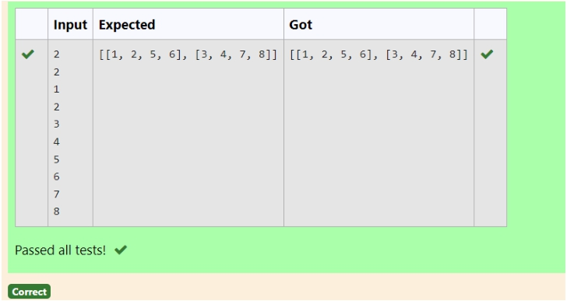

Sample test case

Sample input 2

2 1 3 5 7 2 4 6 8

Sample Output

[[1, 3, 2, 4], [5, 7, 6, 8]]

**Department of Computer Science and Engineering** | **Rajalakshmi Engineering College** 103

**Ex. No.** **:** **5.7** **Date:** 03.05.2024

**Register No.:** 230701143 **Name:** KA RTH IKH A SRE M

**Merge List**

Write a Python program to Zip two given lists of lists.

Input:

m : row size

n: column size

list1 and list 2 : Two lists Output

Zipped List : List which combined both list1 and list2

m =int(input()) n=int(input()) l1=[]

l2=[] l=[]

for iin range(m ):

tem p=[]

for iin range(n):

tem p.append(int(input())) l1.append(tem p)

for iin range(m ):

tem p=[]

for iin range(n):

tem p.append(int(input())) l2.append(tem p)

for iin range(m ): l.append(l1[i]+l2[i])

print(l)

**Department of Computer Science and Engineering** | **Rajalakshmi Engineering College** 104

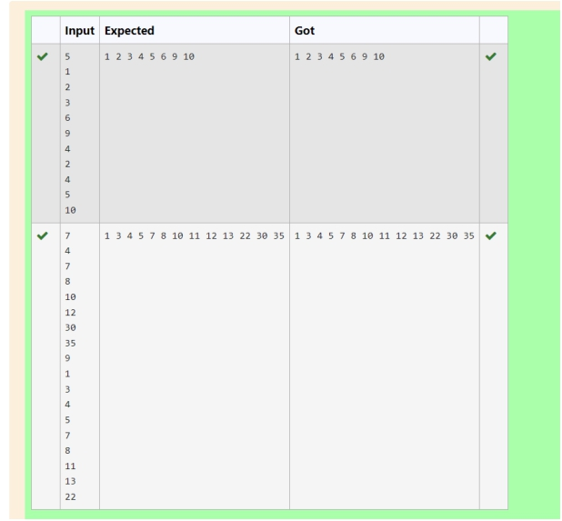

Sample Input 1

5 1 2 3 6 9 4 2 4 5 10

Sample Output 1

1 2 3 4 5 6 9 10

**Department of Computer Science and Engineering** | **Rajalakshmi Engineering College** 105

**Ex. No. Register No.:**

**:**

**5.8**

230701143

**Name:**

**Date:** 03.05.2024

KA RTH IKH A SRE M

**Merge Two Sorted Arrays Without Duplication**

Output is a merged array without duplicates.

Input Format

N1 - no of elements in array 1 Array elements for array 1

N2 - no of elements in array 2 Array elements for array2 Output Format

Display the merged array

l1=set() l2=set() a=int(input())

for iin range(a): l1.add(int(input()))

b=int(input()) for iin range(b):

l2.add(int(input())) l1.update(l2)

m =sorted(list(l1))

for iin m :

print(i,end='')

**Department of Computer Science and Engineering** | **Rajalakshmi Engineering College** 106

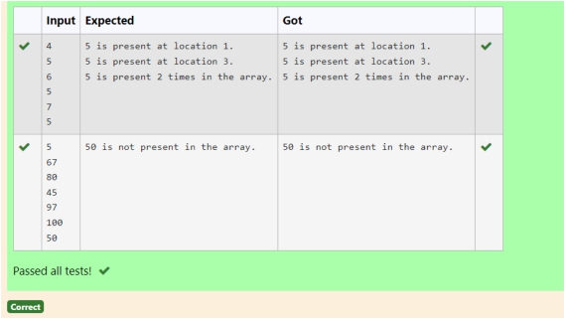

For example, if there are 4 elements in the array: 5

6 5 7

If the element to search is 5 then the output will be:

5 is present at location 1

5 is present at location 3

5 is present 2 times in the array. Sample Test Cases

Test Case 1 Input

4 5 6 5 7 5

Output

5 is present at location 1.

5 is present at location 3.

5 is present 2 times in the array.

Test Case 2

Input

5 67 80 45 97

100

50

Output

50 is not present in the array.

**Department of Computer Science and Engineering** | **Rajalakshmi Engineering College** 107

**Ex. No. Register No.:**

**:**

**5.9**

230701143

**Name:**

**Date:** 03.05.2024

KA RTH IKH A SRE M

**Print Element Location**

Write a program to print all the locations at which a particular element (taken as input) is found in a list and also print the total number of times it occurs in the list. The location starts from 1.

a=[] n=int(input()) for iin range(n):

a.append(int(input()))

f=int(input())

l=1 t=False c=0

for iin a: if i==f:

print("% d is present at location % d."% (f,l)) c+=1

l+=1

if c!=0:

print("% d is present % d tim es in the array."% (f,c))

else:

print("% d is not present in the array."% f)

**Department of Computer Science and Engineering** | **Rajalakshmi Engineering College** 108

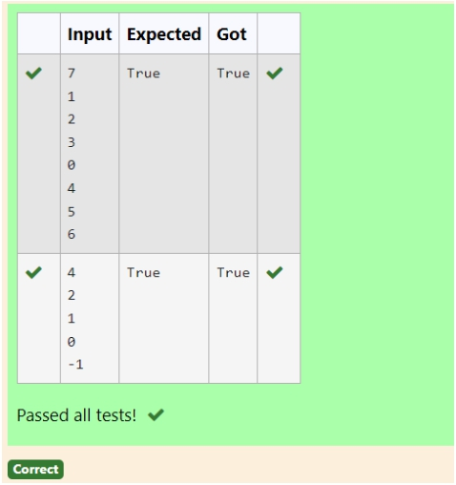

Sample Test Case

Input

7 1 2 3 0 4 5 6

Output

True

**Department of Computer Science and Engineering** | **Rajalakshmi Engineering College** 109

**Ex. No. Register No.:**

**:**

**5.10**

230701143

**Name:**

**Date:** 03.05.2024

KA RTH IKH A SRE M

**Strictly increasing**

Write a Python program to check if a given list is strictly increasing or not. Moreover, If removing only one element from the list results in a strictly increasing list, we still consider the list true

Input:

n : Number of elements List1: List of values Output

Print "True" if list is strictly increasing or decreasing else print "False"

l=[]

tem p=l a=int(input()) for iin range(a):

s=int(input()) l.append(s)

l1=sorted(l)

k=l1[0] for iin l:

if(i-1!=k): l.rem ove(i) l1.rem ove(i) break

else:

k=i

print(l==l1 or l==l1[::-1])

**Department of Computer Science and Engineering** | **Rajalakshmi Engineering College** 110

**Department of Computer Science and Engineering** | **Rajalakshmi Engineering College** 111

**06 - Strings in Python**

**Department of Computer Science and Engineering** | **Rajalakshmi Engineering College** 112

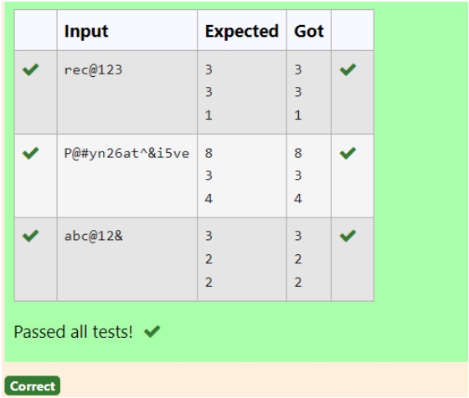

For example:

Input Result rec@123

3 3 1

**Department of Computer Science and Engineering** | **Rajalakshmi Engineering College** 113

**Ex. No. Register No.:**

**:**

**6.1**

230701143

**Name:**

**Date:** 04.05.2024

KA RTH IKH A SRE M

**Count Chars**

Write a python program to count all letters, digits, and special symbols respectively from a given string

s=input() l=n=c=0 for iin s:

if(i.isalpha()):

l+=1

elif(i.isdecim al()):

n+=1

else:

c+=1 print(l) print(n) print(c)

**Department of Computer Science and Engineering** | **Rajalakshmi Engineering College** 114

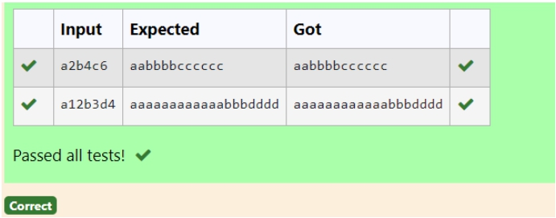

Sample Input 1 a2b4c6

Sample Output 1 aabbbbcccccc

**Department of Computer Science and Engineering** | **Rajalakshmi Engineering College** 115

**Ex. No. Register No.:**

**:**

**6.2**

230701143

**Name:**

**Date:** 04.05.2024

KA RTH IKH A SRE M

**Decompress the String**

Assume that the given string has enough memory. Don't use any extra space(IN- PLACE)

s=input() tem p=0 char='' for iin s:

if i.isalpha(): print(char*tem p,end='') tem p=0

char=i

else:

tem p=tem p*10+int(i) print(char*tem p,end='')

**Department of Computer Science and Engineering** | **Rajalakshmi Engineering College** 116

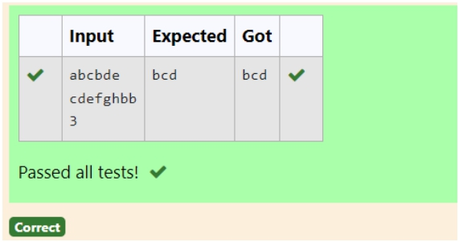

Input Format:

The first line contains S1. The second line contains S2. The third line contains N.

Output Format:

The first line contains the N characters present in S1 which are also present in S2. Boundary Conditions:

2 <= N <= 10

2 <= Length of S1, S2 <= 1000 Example Input/Output 1: Input:

abcbde cdefghbb 3

Output: bcd Note:

b occurs twice in common but must be printed only once.

**Department of Computer Science and Engineering** | **Rajalakshmi Engineering College** 117

**Ex. No.** **:** **6.3** **Date:** 04.05.2024

**Register No.:** 230701143 **Name:** KA RTH IKH A SRE M

**First N Common Chars**

Two string values S1, S2 are passed as the input. The program must print first N characters present in S1 which are also present in S2.

s1 = input().strip() s2 = input().strip()

n = int(input().strip())

com m on_chars = set(s1) & set(s2) result = []

for char in s1:

if char in com m on_chars:

result.append(char)

com m on_chars.rem ove(char) if len(result) == n:

break

print(''.join(result))

**Department of Computer Science and Engineering** | **Rajalakshmi Engineering College** 118

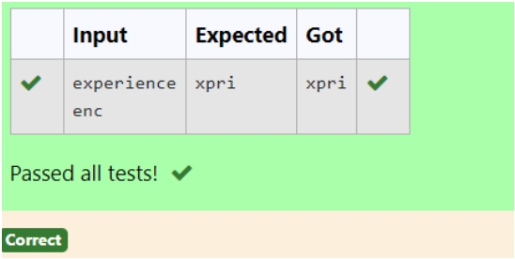

Sample Input 1 experience

enc

Sample Output 1 xpri

**Department of Computer Science and Engineering** | **Rajalakshmi Engineering College** 119

**Ex. No.** **:** **6.4** **Date:** 04.05.2024

**Register No.:** 230701143 **Name:** KA RTH IKH A SRE M

**Remove Characters**

Given two Strings s1 and s2, remove all the characters from s1 which is present in s2.

Constraints

1<= string length <= 200

s1=list(input()) s2=list(input()) for iin s2:

w hile iin s1:

s1.rem ove(i) print(''.join(s1))

**Department of Computer Science and Engineering** | **Rajalakshmi Engineering College** 120

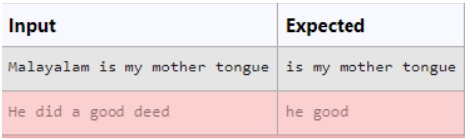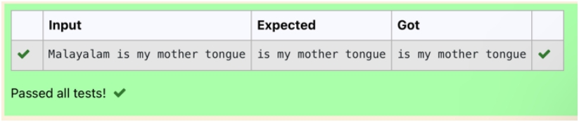

For example:

**Department of Computer Science and Engineering** | **Rajalakshmi Engineering College** 121

**Ex. No.** **:** **6.5** **Date:** 04.05.2024

**Register No.:**230701143 **Name:** KA RTH IKH A SRE M

**Remove Palindrome Words**

String should contain only the words are not palindrome.

Sample Input 1

Malayalam is my mother tongue

Sample Output 1

is my mother tongue

a=[] a=input() b=a. split() for iin b:

k=i.low er() if k!=k[::-1]:

print(k,end='')

**Department of Computer Science and Engineering** | **Rajalakshmi Engineering College** 122

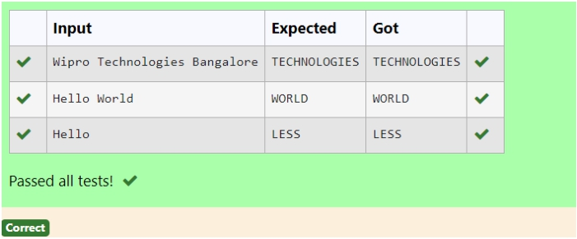

For example:

Input Result

Wipro Technologies Bangalore

TECHNOLOGIES Hello World WORLD

Hello

LESS

**Department of Computer Science and Engineering** | **Rajalakshmi Engineering College** 123

**Ex. No.** **:** **6.6** **Date:** 04.05.2024

**Register No.:** 230701143 **Name:** KA RTH IKH A SRE M

**Return Second World in Uppercase**

Write a program that takes as input a string (sentence), and returns its second word in uppercase.

For example:

If input is “Wipro Technologies Bangalore” the function should return

“TECHNOLOGIES”

If input is “Hello World” the function should return “WORLD” If input is “Hello” the program should return “LESS”

NOTE 1: If input is a sentence with less than 2 words, the program should return the word “LESS”.

NOTE 2: The result should have no leading or trailing spaces.

s=input().split() if(len(s)>=2):

print(s[1].upper())

else:

print("LESS")

**Department of Computer Science and Engineering** | **Rajalakshmi Engineering College** 124

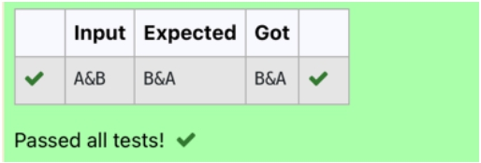

Input: A&B Output: B&A

Explanation: As we ignore '&' and

As we ignore '&' and then reverse, so answer is "B&A".

For example:

Input Result A&x#

x&A#

**Department of Computer Science and Engineering** | **Rajalakshmi Engineering College** 125

**Ex. No. Register No.:**

**:**

**6.7**

230701143

**Name:**

**Date:** 04.05.2024

KA RTH IKH A SRE M

**Revers String**

Reverse a string without affecting special characters. Given a string S, containing special characters and all the alphabets, reverse the string without affecting the positions of the special characters.

def reverse_string(s): s = list(s)

l,r = 0,len(s) -1

w hile l< r:

if not s[l].isalpha(): l+= 1

elif not s[r].isalpha(): r -= 1

else:

s[l],s[r]= s[r],s[l] l+= 1

r -= 1

return ''.join(s)

# Test C ases

print(reverse_string(input())) # O utput:"B&A "

**Department of Computer Science and Engineering** | **Rajalakshmi Engineering College** 126

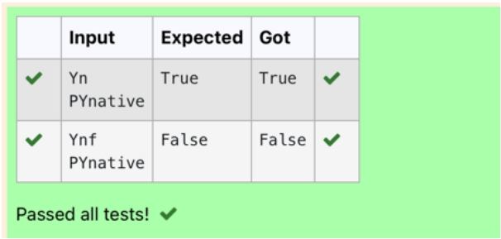

For example:

Input Result Yn

PYnative

True

**Department of Computer Science and Engineering** | **Rajalakshmi Engineering College** 127

**Ex. No.** **:** **6.8** **Date:** 04.05.2024

**Register No.:** 230701143 **Name:** KA RTH IKH A SRE M

**String characters balance Test**

Write a program to check if two strings are balanced. For example, strings s1 and s2 are balanced if all the characters in the s1 are present in s2. The character’s position doesn’t matter. If balanced display as "true" ,otherwise "false".

a=input() b=input() if a in b:

print("True")

else:

print("False")

**Department of Computer Science and Engineering** | **Rajalakshmi Engineering College** 128

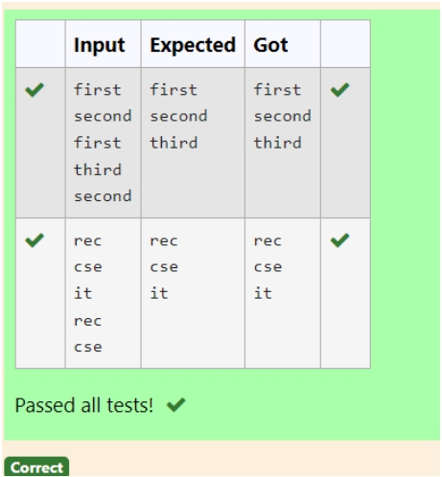

**Input:** first second first third second

then your program should display:

**Output:** first second third

**Department of Computer Science and Engineering** | **Rajalakshmi Engineering College** 129

**Ex. No.** **:** **6.9** **Date:** 04.05.2024

**Register No.:** 230701143 **Name:** KA RTH IKH A SRE M

**Unique Names**

In this exercise, you will create a program that reads words from the user until the user enters a blank line. After the user enters a blank line your program should display each word entered by the user exactly once. The words should be displayed in the same order that they were first entered. For example, if the user enters:

l=[] try:

w hile True:

s=input()

if s not in l: l.append(s)

except EO FError:

print('\n'.join(l))

**Department of Computer Science and Engineering** | **Rajalakshmi Engineering College** 130

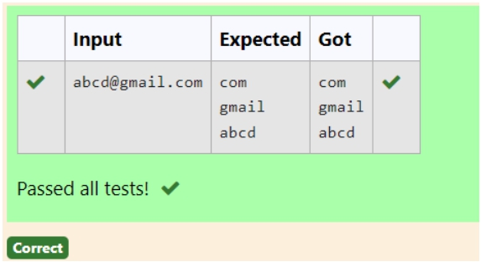

Example Input/Output 1:

**Input**: vijayakumar.r@rajalakshmi.edu.in **Output**:

edu.in rajalakshmi vijayakumar.r

**Department of Computer Science and Engineering** | **Rajalakshmi Engineering College** 131

**Ex. No.** **:** **6.10** **Date:** 04.05.2024

**Register No.:** 230701143 **Name:** KA RTH IKH A SRE M

**Username Domain Extension**

Given a string S which is of the format USERNAME@DOMAIN.EXTENSION, the program must print the EXTENSION, DOMAIN, USERNAME in the reverse order.

**Input Format**:

The first line contains S.

**Output Format**:

The first line contains EXTENSION. The second line contains DOMAIN. The third line contains USERNAME.

**Boundary Condition:**

1 <= Length of S <= 100

s=input() f=s.find('@ ') r=s.find('.') print(s[r+1:]) print(s[f+1:r]) print(s[:f])

**Department of Computer Science and Engineering** | **Rajalakshmi Engineering College** 132

**Department of Computer Science and Engineering** | **Rajalakshmi Engineering College** 133

**07 - Functions**

**Department of Computer Science and Engineering** | **Rajalakshmi Engineering College** 134

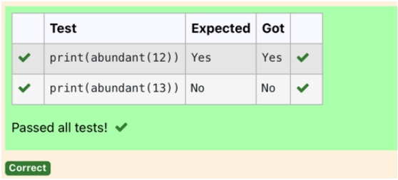

**Example input:** 12

**Output**:

Yes

Explanation

The proper divisors of 12 are: 1, 2, 3, 4, 6, whose sum is 1 + 2 + 3 + 4 + 6 = 16. Since sum of proper divisors is greater than the given number, 12 is an abundant number. **Example input:**

13 **Output**: No

**Explanation**

The proper divisors of 13 is: 1, whose sum is 1. Since sum of proper divisors is not greater than the given number, 13 is not an abundant number.

For example:

Test Result

print(abundant(12)) Yes

print(abundant(13)) No

**Department of Computer Science and Engineering** | **Rajalakshmi Engineering College** 135

**Ex. No.** **:** **7.1** **Date:** 01.06.2024

**Register No.:** 230701143 **Name:** KA RTH IKH A SRE M

**Abundant Number**

An abundant number is a number for which the sum of its proper divisors is greater than the number itself. Proper divisors of the number are those that are strictly lesser than the number.

**Input Format**:

Take input an integer from stdin **Output Format:**

Return Yes if given number is Abundant. Otherwise, print No

l,s=[],0

for iin range(1,int(n//2)+1):

if(n% i==0): l.append(i)

for iin l:

s+=i

if(s>n):

return("Yes")

else:

return("N o")

**Department of Computer Science and Engineering** | **Rajalakshmi Engineering College** 136

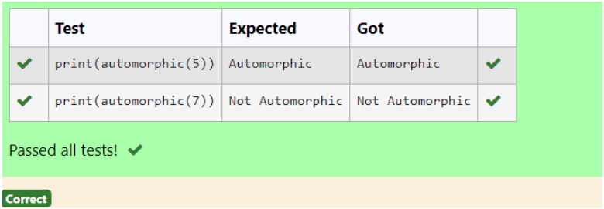

Input Format:

Take a Integer from Stdin Output Format:

Print Automorphic if given number is Automorphic number, otherwise Not

Automorphic

Example input: 5 Output: Automorphic Example input: 25 Output: Automorphic Example input: 7 Output: Not Automorphic

For example:

Test Result

print(automorphic(5)) Automorphic

**Department of Computer Science and Engineering** | **Rajalakshmi Engineering College** 137

**Ex. No. Register No.:**

**:**

**7.2**

230701143

**Name:**

**Date:** 01.06.2024

KA RTH IKH A SRE M

**Automorphic number or not**

An automorphic number is a number whose square ends with the number itself. For example, 5 is an automorphic number because 5*5 =25. The last digit is 5 which same as the given number.

If the number is not valid, it should display “Invalid input”.

If it is an automorphic number display “Automorphic” else display “Not Automorphic”.

def autom orphic(n):

sq=n*n

sq=str(sq)

if sq[-len(str(n)):]==str(n):

return "A utom orphic"

else:

return "N ot A utom orphic"

**Department of Computer Science and Engineering** | **Rajalakshmi Engineering College** 138

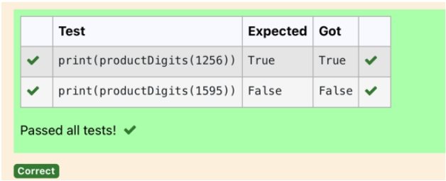

Input Format:

Take an input integer from stdin. Output Format:

Print TRUE or FALSE. Example Input:

1256 Output: TRUE

Example Input:

1595 Output: FALSE

For example:

**Test** **Result**

print(productDigits(1256)) True print(productDigits(1595)) False

**Department of Computer Science and Engineering** | **Rajalakshmi Engineering College** 139

**Ex. No. Register No.:**

**:**

**7.3**

230701143

**Name:**

**Date:** 01.06.2024

KA RTH IKH A SRE M

**Check Product of Digits**

Write a code to check whether product of digits at even places is divisible by sum of digits at odd place of a positive integer.

def productD igits(n):

a=str(n)

s,p=0,1

for iin range(0,len(a),2):

s+=int(a[i])

for iin range(1,len(a),2):

p*=int(a[i])

if(p% s==0):

return("True")

else:

return("False")

**Department of Computer Science and Engineering** | **Rajalakshmi Engineering College** 140

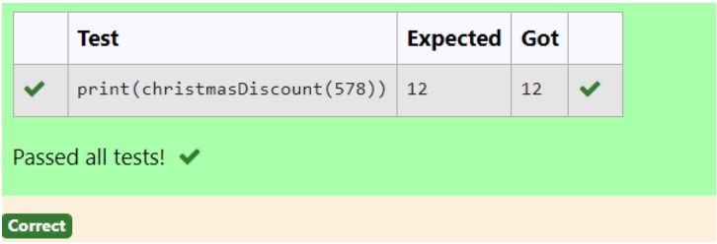

Input

The input consists of an integer orderValue, representing the total bill amount.

Output

Print an integer representing the discount value for the given total bill amount. Example Input

578 Output 12

**For example:**

**Test** **Result**

print(christmasDiscount(578)) 12

**Department of Computer Science and Engineering** | **Rajalakshmi Engineering College** 141

**Ex. No.** **:** **7.4** **Date:** 01.06.2024

**Register No.:** 230701143 **Name:** KA RTH IKH A SRE M

**Christmas Discount**

An e-commerce company plans to give their customers a special discount for Christmas. They are planning to offer a flat discount. The discount value is calculated as the sum of all the prime digits in the total bill amount.

Write an python code to find the discount value for the given total bill amount. **Constraints**

1 <= orderValue< 10e100000

def is_prim e(n): if n <= 1:

return False

for iin range(2,int(n**0.5) + 1):

if n % i== 0:

return False return True

def christm asD iscount(orderValue):

discount = 0

for digit in str(orderValue):

if is_prim e(int(digit)):

discount += int(digit) return discount

**Department of Computer Science and Engineering** | **Rajalakshmi Engineering College** 142

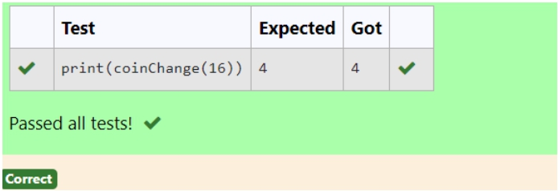

Input Format:

Integer input from stdin. Output Format:

return the minimum number of coins required to meet the given target. Example Input:

16 Output: 4

Explanation:

We need only 4 coins of value 4 each

Example Input:

25 Output: 7

Explanation:

We need 6 coins of 4 value, and 1 coin of 1 value

**Department of Computer Science and Engineering** | **Rajalakshmi Engineering College** 143

**Ex. No. Register No.:**

**:**

**7.5**

230701143

**Name:**

**Date:** 01.06.2024

KA RTH IKH A SRE M

**Coin Change**

complete function to implement coin change making problem i.e. finding the minimum number of coins of certain denominations that add up to given amount of money.

The only available coins are of values 1, 2, 3, 4

def coinC hange(n):

denom inations = [1,2,3,4]

m in_coins = [float('inf')]* (n + 1)

m in_coins[0]= 0

for am ount in range(1,n + 1):

for coin in denom inations:

if coin <= am ount:

m in_coins[am ount]= m in(m in_coins[am ount],m in_coins[am ount -

coin]+ 1)

return m in_coins[n]

**Department of Computer Science and Engineering** | **Rajalakshmi Engineering College** 144

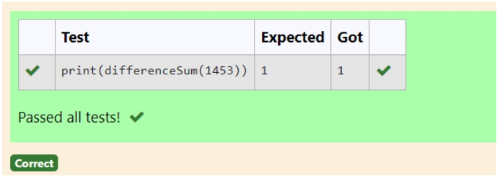

Input Format:

Take a number in the form of String from stdin. Output Format:

Print the difference between sum of even and odd digits Example input:

1453 Output: 1

Explanation:

Here, sum of even digits is 4 + 3 = 7 sum of odd digits is 1 + 5 = 6. Difference is 1.

Note that we are always taking absolute difference

**Department of Computer Science and Engineering** | **Rajalakshmi Engineering College** 145

**Ex. No. Register No.:**

**:**

**7.6**

230701143

**Name:**

**Date:** 01.06.2024

KA RTH IKH A SRE M

**Difference Sum**

Given a number with maximum of 100 digits as input, find the difference between the sum of odd and even position digits.

def differenceSum (n): n_str = str(n) even_sum = 0 odd_sum = 0

for i,digit in enum erate(n_str):

digit = int(digit) if i% 2 == 0:

even_sum += digit

else:

odd_sum += digit

difference = abs(even_sum -odd_sum ) return difference

**Department of Computer Science and Engineering** | **Rajalakshmi Engineering College** 146

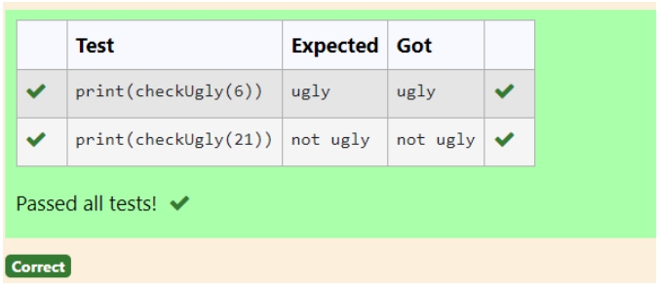

**For example:**

**Test**

**Result**

print(checkUgly(6)) ugly

print(checkUgly(21)) not ugly

**Department of Computer Science and Engineering** | **Rajalakshmi Engineering College** 147

**Ex. No. Register No.:**

**:**

**7.7**

230701143

**Name:**

**Date:** 01.06.2024

KA RTH IKH A SRE M

**Ugly number**

A number is considered to be ugly if its only prime factors are 2, 3 or 5. [1, 2, 3, 4, 5, 6, 8, 9, 10, 12, 15, …] is the sequence of ugly numbers. Task:

complete the function which takes a number n as input and checks if it's an ugly

number. return ugly if it is ugly, else return not ugly Hint:

An ugly number U can be expressed as: U = 2^a * 3^b * 5^c, where a, b and c are nonnegative integers.

def checkU gly(n): if n <= 0:

return "not ugly"

w hile n % 2 == 0: n //= 2

w hile n % 3 == 0:

n //= 3

w hile n % 5 == 0: n //= 5

return "ugly" if n == 1 else "not ugly"

**Department of Computer Science and Engineering** | **Rajalakshmi Engineering College** 148

**Department of Computer Science and Engineering** | **Rajalakshmi Engineering College** 149

**08 – Tuple/Set**

**Department of Computer Science and Engineering** | **Rajalakshmi Engineering College** 150

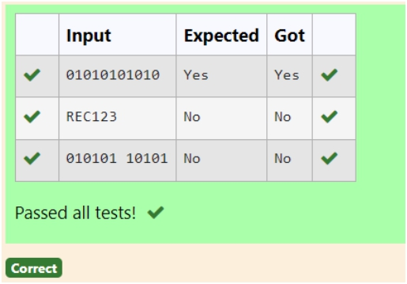

Examples:

Input: str = "01010101010" Output: Yes

Input: str = "REC101" Output: No

**For example:**

**Input** **Result**

01010101010 Yes

010101 10101 No

**Department of Computer Science and Engineering** | **Rajalakshmi Engineering College** 151

**Ex. No. Register No.:**

**:**

**8.1**

230701143

**Name:**

**Date:** 01.06.2024

KA RTH IKH A SRE M

**Binary String**

Coders here is a simple task for you, Given string str. Your task is to check whether it is a binary string or not by using python set.

def is_binary_string(s):

binary_set = {'0','1'}

return set(s) <= binary_set s = input("")

if is_binary_string(s):

print("Yes")

else:

print("N o")

**Department of Computer Science and Engineering** | **Rajalakshmi Engineering College** 152

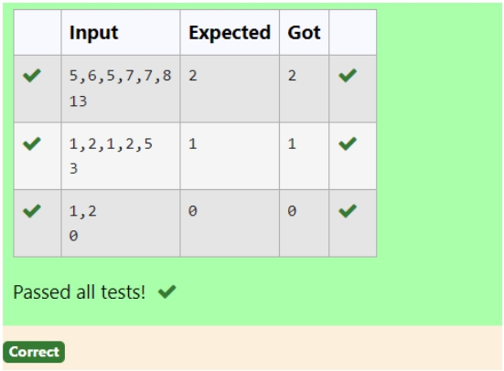

**Examples:**

**Input**: t = (5, 6, 5, 7, 7, 8 ), K = 13

**Output**: 2

Explanation:

Pairs with sum K( = 13) are {(5, 8), (6, 7), (6, 7)}.

Therefore, distinct pairs with sum K( = 13) are { (5, 8), (6, 7) }. Therefore, the required output is 2.

For example:

Input Result

1,2,1,2,5

3

1

1,2

0

0

**Department of Computer Science and Engineering** | **Rajalakshmi Engineering College** 153

**Ex. No. Register No.:**

**:**

**8.2**

230701143

**Name:**

**Date:** 01.06.2024

KA RTH IKH A SRE M

**Check Pair**

Given a tuple and a positive integer k, the task is to find the count of distinct pairs in the tuple whose sum is equal to **K**.

a=input("") l=a.split(",") k=int(input()) t=[]

r=[]

for iin range (len(l)):

for jin range (1,len(l)):

f=[]

if (int(l[i])+int(l[j]))==k: f.append(int(l[i])) f.append(int(l[j])) f.sort()

t.append(f)

for iin t:

if inot in r:

r.append(i) print(len(r))

**Department of Computer Science and Engineering** | **Rajalakshmi Engineering College** 154

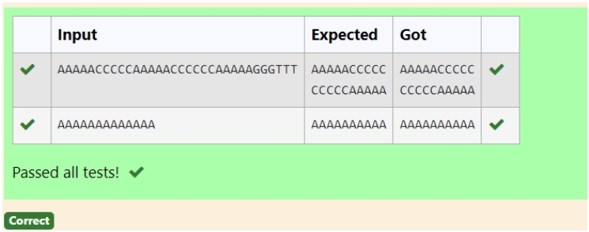

**Example 1:**

**Input:** s = "AAAAACCCCCAAAAACCCCCCAAAAAGGGTTT" **Output:** ["AAAAACCCCC","CCCCCAAAAA"]

**Example 2:**

**Input:** s = "AAAAAAAAAAAAA" **Output:** ["AAAAAAAAAA"]

**For example:**

**Input** **Result**

AAAAACCCCCAAAAACCCCCCAAAAAGGGTTT AAAAACCCCC

CCCCCAAAAA

**Department of Computer Science and Engineering** | **Rajalakshmi Engineering College** 155

**Ex. No.** **:** **8.3** **Date:** 01.06.2024

**Register No.:** 230701143 **Name:** KA RTH IKH A SRE M

**DNA Sequence**

The **DNA sequence** is composed of a series of nucleotides abbreviated as 'A', 'C', 'G', and 'T'.

For example, "ACGAATTCCG" is a **DNA sequence**.

When studying **DNA**, it is useful to identify repeated sequences within the DNA.

Given a string s that represents a **DNA sequence**, return all the **10-letter-**

**long** sequences (substrings) that occur more than once in a DNA molecule. You may return the answer in **any order**.

s=input('')

if len(s) < 10: l=[]

a= {} b= set()

for iin range(len(s) -9):

x= s[i:i+10] if x in a:

b.add(x)

else:

a[x]= 1 l=list(b)

for iin l:

print(i)

**Department of Computer Science and Engineering** | **Rajalakshmi Engineering College** 156

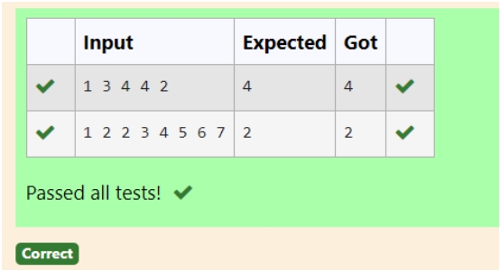

**Example 1:**

**Input:** nums = [1,3,4,2,2] **Output:** 2

**Example 2:**

**Input:** nums = [3,1,3,4,2] **Output:** 3

**For example:**

**Input** **Result**

1 3 4 4 2 4

**Department of Computer Science and Engineering** | **Rajalakshmi Engineering College** 157

**Ex. No. Register No.:**

**:**

**8.4**

230701143

**Name:**

**Date:** 01.06.2024

KA RTH IKH A SRE M

**Print repeated no**

Given an array of integers nums containing n + 1 integers where each integer is in the

range [1, n] inclusive.There is only **one** **repeated** **number** in nums,

return *this repeated number*. Solve the problem using [set](http://118.185.187.137/moodle/mod/resource/view.php?id=734).

def findD uplicate(num s):

seen = set() # Initialize an em pty set to keep track of seen num bers

for num in num s:

if num in seen:# If the num ber is already in the set,it is the duplicate

return num

seen.add(num ) # O therw ise,add the num ber to the set

user_input = input()

num s = list(m ap(int,user_input.split())) duplicate = findD uplicate(num s) print(duplicate)

**Department of Computer Science and Engineering** | **Rajalakshmi Engineering College** 158

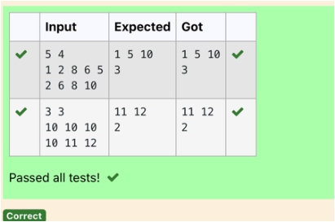

[Sample](https://www.rajalakshmicolleges.net/moodle/mod/quiz/view.php?id=5127) Input:

5 4

1 2 8 6 5

2 6 8 10

[Sample](https://www.rajalakshmicolleges.net/moodle/mod/quiz/view.php?id=5127) Output:

1 5 10

3

[Sample](https://www.rajalakshmicolleges.net/moodle/mod/quiz/view.php?id=5127) Input:

5 5

1 2 3 4 5

1 2 3 4 5

[Sample](https://www.rajalakshmicolleges.net/moodle/mod/quiz/view.php?id=5127) Output:

NO SUCH ELEMENTS

**For example:**

**Input** **Result**

5 4

1 2 8 6 5

2 6 8 10

1 5 10 3

**Department of Computer Science and Engineering** | **Rajalakshmi Engineering College** 159

**Ex. No.** **:** **8.5** **Date:** 01.06.2024

**Register No.:** 230701143 **Name:** KA RTH IKH A SRE M

**Remove repeated**

Write a program to eliminate the common elements in the given 2 arrays and print only the non-repeating elements and the total number of such non-repeating elements.

Input Format:

The first line contains space-separated values, denoting the size of the two arrays in integer format respectively.

The next two lines contain the space-separated integer arrays to be compared.

d=[] b=input() c=input()

b=tuple(b.split(" ")) c=tuple(c.split(" ")) for iin b:

if inot in c:

d.append(i)

for iin c:

if inot in b:

d.append(i)

for iin range(len(d)):

print(int(d[i]),end='')

print() print(len(d))

**Department of Computer Science and Engineering** | **Rajalakshmi Engineering College** 160

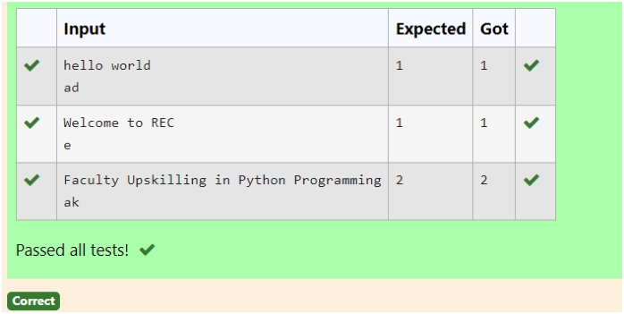

Example 1:

Input: text = "hello world", brokenLetters = "ad" Output:

1

Explanation: We cannot type "world" because the 'd' key is broken.

**For example:**

**Input** **Result**

hello world ad

1

**Department of Computer Science and Engineering** | **Rajalakshmi Engineering College** 161

**Ex. No.** **:** **8.6** **Date:** 01.06.2024

**Register No.:** 230701143 **Name:** KA RTH IKH A SRE M

**Malfunctioning Keyboard**

There is a malfunctioning keyboard where some letter keys do not work. All other keys on the keyboard work properly.

Given a string text of words separated by a single space (no leading or trailing spaces) and a string brokenLetters of all distinct letter keys that are broken, return the number of words in text you can fully type using this keyboard.

s=input() b=input() c=0

t=[] l=s.split('') for iin b:

for jin l:

if inot in j: t.append(j) break

r=[]

for iin t:

if inot in r:

r.append(i) print(len(r))

**Department of Computer Science and Engineering** | **Rajalakshmi Engineering College** 162

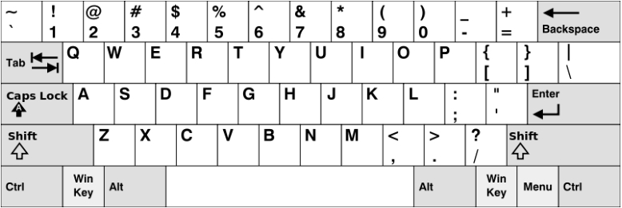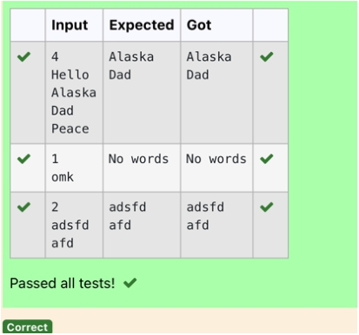

**Example 1:**

**Input:** words = ["Hello","Alaska","Dad","Peace"] **Output:** ["Alaska","Dad"]

**Example 2:**

**Input:** words = ["omk"] **Output:** []

**Example 3:**

**Input:** words = ["adsdf","sfd"] **Output:** ["adsdf","sfd"]

**For example:**

**Input** **Result**

4

Hello Alaska Dad Peace

Alaska

Dad

**Department of Computer Science and Engineering** | **Rajalakshmi Engineering College** 163

the first row consists of the characters "qwertyuiop",

the second row consists of the characters "asdfghjkl", and

the third row consists of the characters "zxcvbnm".

**Ex. No.** **:** **8.7** **Date:** 01.06.2024

**Register No.:** 230701143 **Name:** KA RTH IKH A SRE M

**American keyboard**

Given an array of strings words, return *the words that can be typed using letters of the alphabet on only one row of American keyboard like the image below*.

In the **American keyboard**:







def findW ords(w ords): row 1 = set('qw ertyuiop') row 2 = set('asdfghjkl') row 3 = set('zxcvbnm ')

result = []

for w ord in w ords:

w = set(w ord.low er())

if w .issubset(row 1) or w .issubset(row 2) or w .issubset(row 3):

result.append(w ord)

if len(result) == 0:

print("N o w ords")

else:

for iin result:

print(i)

a = int(input())

arr = [input() for iin range(a)] findW ords(arr)

**Department of Computer Science and Engineering** | **Rajalakshmi Engineering College** 164

**Department of Computer Science and Engineering** | **Rajalakshmi Engineering College** 165

**09 – Dictionary**

**Department of Computer Science and Engineering** | **Rajalakshmi Engineering College** 166

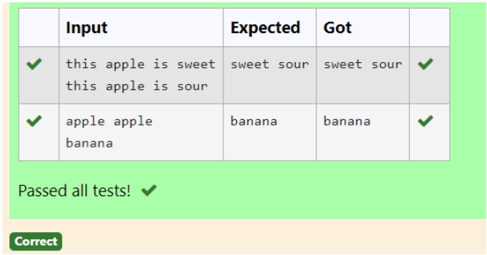

Example 1:

Input: s1 = "this apple is sweet", s2 = "this apple is sour" Output: ["sweet","sour"]

Example 2:

Input: s1 = "apple apple", s2 = "banana"

Output: ["banana"]

Constraints:

1 <= s1.length, s2.length <= 200

s1 and s2 consist of lowercase English letters and spaces.

s1 and s2 do not have leading or trailing spaces.

All the words in s1 and s2 are separated by a single space.

Note:

Use dictionary to solve the problem **For example:**

**Input** **Result**

this apple is sweet this apple is sour

sweet sour

**Department of Computer Science and Engineering** | **Rajalakshmi Engineering College** 167

**Ex. No.** **:** **9.1** **Date:** 02.06.2024

**Register No.:** 230701143 **Name:** KA RTH IKH A SRE M

**Uncommon words**

A sentence is a string of single-space separated words where each word consists only of lowercase letters.A word is uncommon if it appears exactly once in one of the sentences, and does not appear in the other sentence.

Given two sentences s1 and s2, return a list of all the uncommon words. You may return the answer in any order.

n =input()

l1 = n.split() n = input() l2 = n.split()

def check(l1,l2):

c1 =[]

for iin l1:

c = l1.count(i) c1.append(c)

for iin range(len(c1)):

if c1[i]== 1 and l1[i]not in l2:

print(l1[i],end =" ")

check(l1,l2) check(l2,l1)

**Department of Computer Science and Engineering** | **Rajalakshmi Engineering College** 168

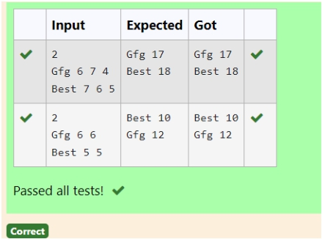

**Input** : test_dict = {‘Gfg’ : [6, 7, 4], ‘best’ : [7, 6, 5]}

**Output** : {‘Gfg’: 17, ‘best’: 18}

**Explanation** : Sorted by sum, and replaced.

**Input** : test_dict = {‘Gfg’ : [8,8], ‘best’ : [5,5]}

**Output** : {‘best’: 10, ‘Gfg’: 16}

**Explanation** : Sorted by sum, and replaced.

Sample Input:

2

Gfg 6 7 4

Best 7 6 5 Sample Output Gfg 17

Best 18

**For example:**

**Input** **Result**

2

Gfg 6 7 4 Best 7 6 5

Gfg 17 Best 18

**Department of Computer Science and Engineering** | **Rajalakshmi Engineering College** 169

**Ex. No. Register No.:**

**:**

**9.2**

230701143

**Name:**

**Date:** 02.06.2024

KA RTH IKH A SRE M

**Sort Dictionary by Values Summation**

Give a dictionary with value lists, sort the keys by summation of values in value list.

n = int(input()) s = {}

w hile n:

l1 = input().split() x = l1.pop(0)

total= sum (m ap(int,l1)) s[x]= total

n -= 1

sorted_dict = dict(sorted(s.item s(),key=lam bda item :item [1])) for key,value in sorted_dict.item s():

print(key,value)

**Department of Computer Science and Engineering** | **Rajalakshmi Engineering College** 170

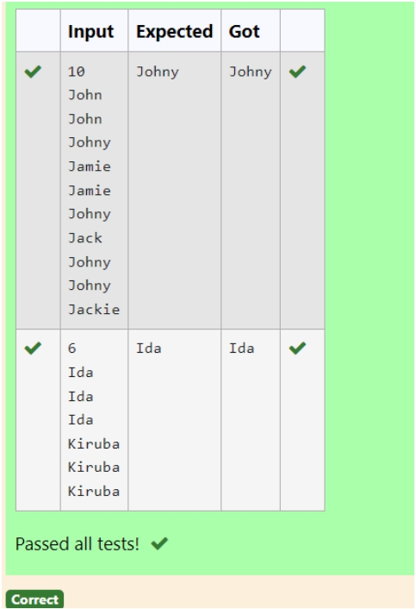

**Examples:**

Input : votes[] = {"john", "johnny", "jackie", "johnny", "john", "jackie", "jamie", "jamie", "john", "johnny", "jamie", "johnny", "john"};

Output : John

We have four Candidates with name as 'John', 'Johnny', 'jamie', 'jackie'. The candidates John and Johny get maximum votes. Since John is alphabetically smaller, we print it. Use dictionary to solve the above problem

**Sample Input:**

10 John John Johny Jamie Jamie Johny Jack Johny Johny Jackie

**Sample Output:** Johny

**For example: Input** **Result**

10 John John Johny Jamie Jamie Johny Jack Johny Johny Jackie

Johny

**Department of Computer Science and Engineering** | **Rajalakshmi Engineering College** 171

**Ex. No.** **:** **9.3** **Date:** 02.06.2024

**Register No.:** 230701143 **Name:** KA RTH IKH A SRE M

**Winner of Election**

Given an array of names of candidates in an election. A candidate name in the array represents a vote cast to the candidate. Print the name of candidates received Max vote. If there is tie, print a lexicographically smaller name.

n = int(input()) l1 = []

for iin range(n): c = input() l1.append(c)

w inner = {} for iin l1:

w inner[i]=l1.count(i)

vote = m ax(w inner.values())

cad = [candidates for candidates ,votes in w inner.item s() if votes==vote]

print(m in(cad))

**Department of Computer Science and Engineering** | **Rajalakshmi Engineering College** 172

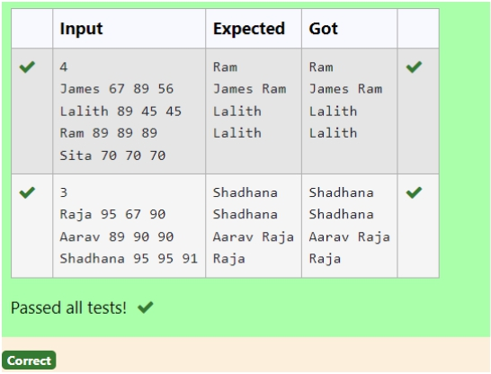

Sample input: 4

James 67 89 56 Lalith 89 45 45 Ram 89 89 89 Sita 70 70 70 Sample Output: Ram

James Ram Lalith Lalith

**Department of Computer Science and Engineering** | **Rajalakshmi Engineering College** 173

**Ex. No. Register No.:**

**:**

**9.4**

230701143

**Name:**

**Date:** 02.06.2024

KA RTH IKH A SRE M

**Student Record**

Create a student dictionary for n students with the student name as key and their test mark assignment mark and lab mark as values. Do the following computations and display the result.

1.Identify the student with the highest [average](https://www.rajalakshmicolleges.net/moodle/mod/quiz/view.php?id=5717) score 2.Identify the student who as the highest Assignment marks 3.Identify the student with the Lowest lab marks

4.Identify the student with the lowest [average](https://www.rajalakshmicolleges.net/moodle/mod/quiz/view.php?id=5717) score Note:

If more than one student has the same score display all the student names

n = int(input()) student ={}

for iin range(n):

nam e,test,assignm ent,lab=input().split() student[nam e]=[int(test),int(assignm ent),int(lab)]

def m ax_avg(student):

avg={}

for nam e,m arks in student.item s():

avg[nam e]=sum (m arks)

m ax_avg = m ax(avg.values())

m ax_stu = [nam e for nam e,m arks in avg.item s() if m arks==m ax_avg ] for iin m ax_stu:

print(i)

def m ax_ass(student):

m ax_ass = m ax(m arks[1]for m arks in student.values())

m ax_stu = [nam e for nam e ,m arks in student.item s() if m ax_ass==m arks[1]]

for iin m ax_stu:

print(i,end =" ") print()

def lab(student):

m in_lab = m in(m arks[2]for m arks in student.values())

m ax_stu = [nam e for nam e ,m arks in student.item s() if m in_lab==m arks[2]]

m ax_stu = sorted(m ax_stu) for iin m ax_stu:

print(i,end =" ") print()

def low _avg(student):

avg={}

for nam e,m arks in student.item s():

avg[nam e]=sum (m arks)

m ax_avg = m in(avg.values())

m ax_stu = [nam e for nam e,m arks in avg.item s() if m arks==m ax_avg ] for iin m ax_stu:

print(i)

m ax_avg(student) m ax_ass(student) lab(student)

low _avg(student)

**Department of Computer Science and Engineering** | **Rajalakshmi Engineering College** 174

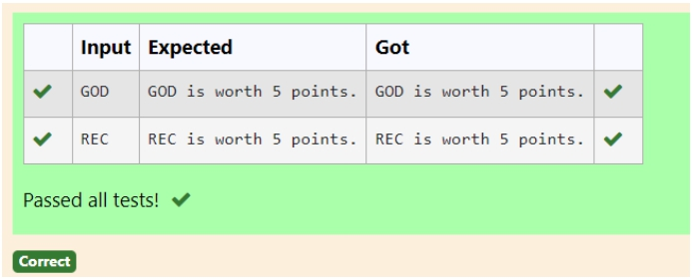

The points associated with each letter are shown below:

Points Letters

1 A, E, I, L, N, O, R, S, T and U

2 D and G

3 B, C, M and P

4 F, H, V, W and Y

5 K

8 J and X

10 Q and Z

[Sample](https://www.rajalakshmicolleges.net/moodle/mod/quiz/view.php?id=5127) Input

REC

[Sample](https://www.rajalakshmicolleges.net/moodle/mod/quiz/view.php?id=5127) Output

REC is worth 5 points.

**Department of Computer Science and Engineering** | **Rajalakshmi Engineering College** 175

**Ex. No. Register No.:**

**:**

**9.5**

230701143

**Name:**

**Date:** 02.06.2024

KA RTH IKH A SRE M

**Scramble Score**

In the game of Scrabble™, each letter has points associated with it. The total score of a word is the sum of the scores of its letters. More common letters are worth fewer points while less common letters are worth more points.

Write a program that computes and displays the Scrabble™ score for a word. Create a dictionary that maps from letters to point values. Then use the dictionary to compute the score.

A Scrabble™ board includes some squares that multiply the value of a letter or the value of an entire word. We will ignore these squares in this exercise.

letter_values = {

'A ':1,'E':1,'I':1,'L':1,'N ':1,'O ':1,'R':1,'S':1,'T':1,'U ':1,

'D ':2,'G ':2,

'B':3,'C ':3,'M ':3,'P':3, 'F':4,'H ':4,'V':4,'W ':4,'Y':4, 'K':5,

'J':8,'X':8,

'Q ':10,'Z':10

}

w ord = input()

points =0

for iin w ord:

points += letter_values[i]

print("{} is w orth {} points.".form at(w ord,points))

**Department of Computer Science and Engineering** | **Rajalakshmi Engineering College** 176

**Department of Computer Science and Engineering** | **Rajalakshmi Engineering College** 177

**10 - Searching & Sorting**

**Department of Computer Science and Engineering** | **Rajalakshmi Engineering College** 178

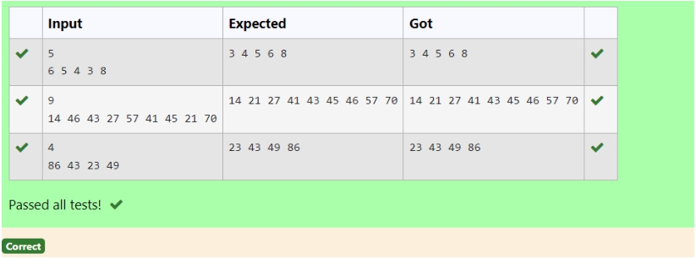

**For example:**

**Input** **Result**

5

6 5 4

3 8

3 4 5

6 8

**Department of Computer Science and Engineering** | **Rajalakshmi Engineering College** 179

**Ex. No. Register No.:**

**:**

**10.1**

230701143

**Name:**

**Date:** 03.06.2024

KA RTH IKH A SRE M

**Merge Sort**

Write a Python program to sort a list of elements using the merge sort algorithm.

def m erge_sort(arr): if len(arr) > 1:

m id = len(arr) // 2 left_half = arr[:m id] right_half = arr[m id:] m erge_sort(left_half)

m erge_sort(right_half)

i= j= k = 0

# M erge the tw o halves

w hile i< len(left_half) and j< len(right_half): if left_half[i]< right_half[j]:

arr[k]= left_half[i]

i+= 1

else:

arr[k]= right_half[j] j+= 1

k += 1

w hile i< len(left_half):

arr[k]= left_half[i] i+= 1

k += 1

w hile j< len(right_half):

arr[k]= right_half[j] j+= 1

k += 1

def print_list(arr):

for num in arr:

print(num ,end=" ")

if __nam e__ == "__m ain__": n = int(input())

elem ents = list(m ap(int,input().split())) m erge_sort(elem ents)

print_list(elem ents)

**Department of Computer Science and Engineering** | **Rajalakshmi Engineering College** 180

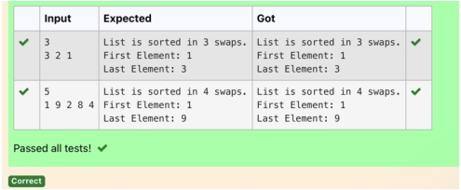

**Input Format**

The first line contains an integer,n , the size of the [list](http://118.185.187.137/moodle/mod/resource/view.php?id=1068) a .

The second line contains n, space-separated integers a[i]. **Constraints**

· 2<=n<=600

· 1<=a[i]<=2x106.

**Output Format**

You must print the following three lines of output:

1. [List](http://118.185.187.137/moodle/mod/resource/view.php?id=1068) is sorted in numSwaps swaps., where numSwaps is the number of swaps that

took place.

2. First Element: firstElement, the *first* element in the sorted [list](http://118.185.187.137/moodle/mod/resource/view.php?id=1068).

3. Last Element: lastElement, the *last* element in the sorted [list](http://118.185.187.137/moodle/mod/resource/view.php?id=1068).

**Sample Input 0** 3

1 2 3

**Sample Output 0**

[List](http://118.185.187.137/moodle/mod/resource/view.php?id=1068) is sorted in 0 swaps.

First Element: 1 Last Element: 3

**For example:**

**Input** **Result**

3

3 2 1

List is sorted in 3 swaps. First Element: 1

Last Element: 3

5

1 9 2

8 4

List is sorted in 4 swaps. First Element: 1

Last Element: 9

**Department of Computer Science and Engineering** | **Rajalakshmi Engineering College** 181

**Ex. No.** **:** **10.2** **Date:** 03.06.2024

**Register No.:** 230701143 **Name:** KA RTH IKH A SRE M

**Bubble Sort**

Given an listof integers, sort the array in ascending order using the *Bubble*

*Sort* algorithm above. Once sorted, print the following three lines:

1. [List](http://118.185.187.137/moodle/mod/resource/view.php?id=1068) is sorted in numSwaps swaps., where numSwaps is the number of swaps that

took place.

2. First Element: firstElement, the *first* element in the sorted [list](http://118.185.187.137/moodle/mod/resource/view.php?id=1068).

3. Last Element: lastElement, the *last* element in the sorted [list](http://118.185.187.137/moodle/mod/resource/view.php?id=1068).

For example, given a worst-case but small array to sort: a=[6,4,1]. It took 3 swaps to

sort the array. Output would be Array is sorted in 3 swaps.

First Element: 1 Last Element: 6

def bubble_sort(arr): n = len(arr)

sw aps = 0

for iin range(n):

for jin range(0,n-i-1): if arr[j]> arr[j+ 1]:

# Sw ap elem ents

arr[j],arr[j+ 1]= arr[j+ 1],arr[j] sw aps += 1

return sw aps

# Input the size of the list n = int(input())

# Input the list of integers

arr = list(m ap(int,input().split()))

# Perform bubble sort and count the num ber of sw aps num _sw aps = bubble_sort(arr)

**Department of Computer Science and Engineering** | **Rajalakshmi Engineering College** 182

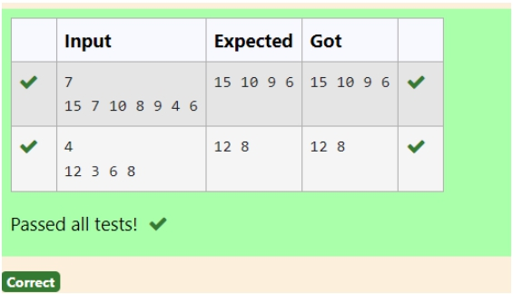

**Input Format**

The first line contains a single integer n , the length of A . The second line contains n space-separated integers,A[i].

**Output Format**

**Print** peak numbers separated by space.

**Sample Input** 5

8 9 10 2 6

**Sample Output**

10 6

**For example: Input** **Result**

4

12 3 6 8

12 8

**Department of Computer Science and Engineering** | **Rajalakshmi Engineering College** 183

**Ex. No. Register No.:**

**:**

**10.3**

230701143

**Name:**

**Date:** 03.06.2024

KA RTH IKH A SRE M

**Peak Element**

Given an [list](http://118.185.187.137/moodle/mod/resource/view.php?id=1068), find peak element in it. A peak element is an element that is greater than its neighbors.

An element a[i] is a peak element if

A[i-1] <= A[i] >=a[i+1] for middle elements. [0<i<n-1]

A[i-1] <= A[i] for last element [i=n-1] A[i]>=A[i+1] for first element [i=0]

def find_peak_elem ents(n,arr):

peaks = []

if n == 1:

peaks.append(arr[0])

elif arr[0]>= arr[1]:

peaks.append(arr[0])

for iin range(1,n -1):

if arr[i]>= arr[i-1]and arr[i]>= arr[i+ 1]:

peaks.append(arr[i]) if arr[n -1]>= arr[n -2]:

peaks.append(arr[n -1])

return peaks

n = int(input())

arr = list(m ap(int,input().split())) print(*find_peak_elem ents(n,arr))

**Department of Computer Science and Engineering** | **Rajalakshmi Engineering College** 184

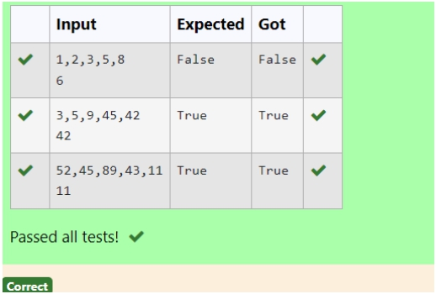

**For example:**

**Input** **Result**

1 2 3 5 8

6

False

3 5 9 45

42

42

True

**Department of Computer Science and Engineering** | **Rajalakshmi Engineering College** 185

**Ex. No. Register No.:**

**:**

**10.4**

230701143

**Name:**

**Date:** 03.06.2024

KA RTH IKH A SRE M

**Binary Search**

Write a Python program for binary search.

array=input()

l=list(m ap(int,array.split(",")))

num =int(input()) low =0 high=len(l)-1

f=1

for iin range(len(l)):

sw apped=False

for jin range(0,len(l)-i-1,1):

if(l[j]>l[j+1]): l[j],l[j+1]=l[j+1],l[j] sw apped=True

if(sw apped==False):

break

w hile(low <=high):

m id=(low +high)//2

if(num ==l[m id]):

f=0

break

elif(num <l[m id]):

high=m id-1

else:

low =m id+1 if(f):

print("False")

else:

print("True")

**Department of Computer Science and Engineering** | **Rajalakshmi Engineering College** 186

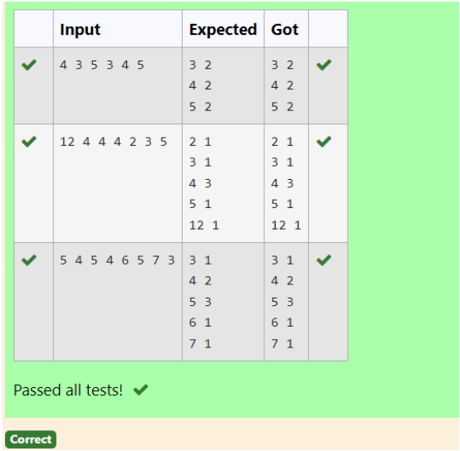

**Input:**

1 68 79 4 90 68 1 4 5

**output:**

1 2

4 2

5 1

68 2

79 1

90 1

**For example:**

**Input** **Result**

4 3 5 3

4 5

3 2

4 2

5 2

**Department of Computer Science and Engineering** | **Rajalakshmi Engineering College** 187

**Ex. No.** **:** **10.5** **Date:** 03.06.2024

**Register No.:** 230701143 **Name:** KA RTH IKH A SRE M

**Frequency of Elements**

To find the frequency of numbers in a list and display in sorted order. **Constraints:**

1<=n, arr[i]<=100

from collections im port C ounter arr = list(m ap(int,input().split())) frequency = C ounter(arr)

sorted_frequency = sorted(frequency.item s()) for num ,count in sorted_frequency:

print(num ,count)

**Department of Computer Science and Engineering** | **Rajalakshmi Engineering College** 188